KRONOS INSTRUCTIONS FOR SUPERVISORS

How to Access:

Classic Interface click here: http://kronos.oru.edu
To obtain the KRONOS desktop icon contact ORU Helpdesk at x6315.

A few things to remember the first time you access the new version of Kronos:
- Kronos works best in Internet Explorer.
- You may be prompted to update Java on your PC.
- Kronos may appear to load slowly at first. It should run faster on subsequent logins.

When you first login to Kronos, you may receive Java security prompts which will ask you to Run or Allow. Typically these can be bypassed by selecting “Do not show this again” and clicking Run or Allow. Below are more details explaining these prompts further.

When you click on your Kronos icon you will see a screen similar to the following screen:
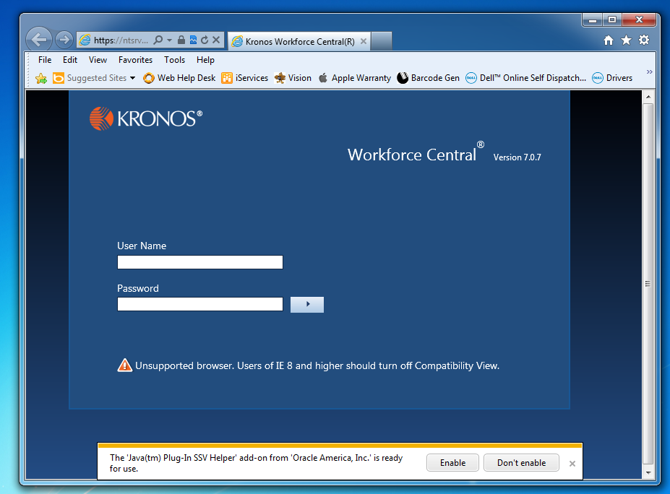
When the page loads, you will need to click “Enable” on this prompt in order for Java to work properly for Kronos.

Internet Explorer and Firefox:

You will likely receive the following prompts the first time you login to Kronos after the upgrade:
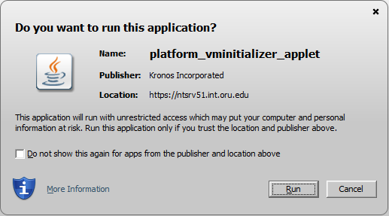

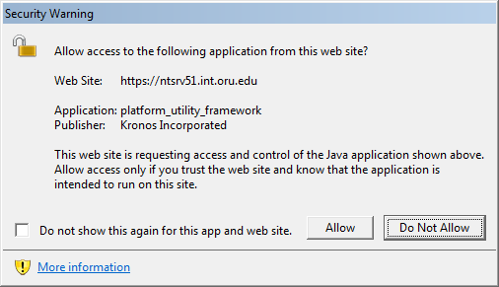

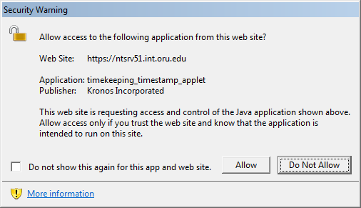

When you receive these prompts, please click “Do not show this again” and click Run or Allow.

Note #1: Failure to click the prompts fast enough the first time may cause Kronos to stop responding. If this occurs, simply close the browser page and open it again. Once all the prompts are acknowledged, Kronos will open and function with no issues.

Note #2: The new version of Kronos has significant security upgrades that were not available in the old version. As a result, the webpage may take up to 30 seconds to load successfully. Once the webpage is loaded, however, it should function normally.

Chrome:
You will likely receive the following screen the first time you login to Kronos after the Recompose:
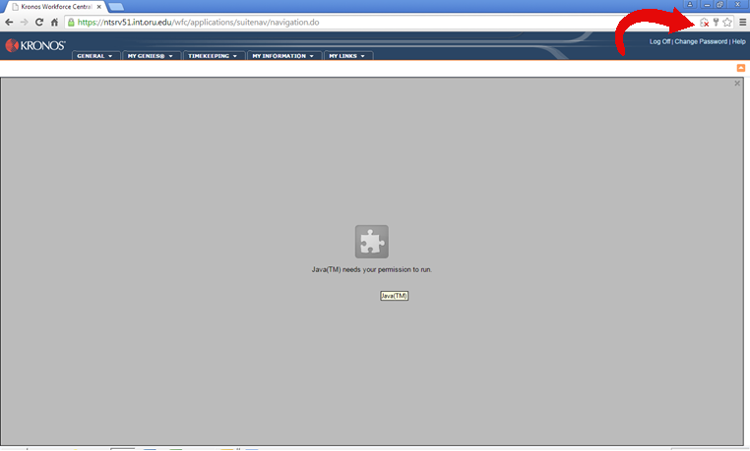

In order to use Kronos on Chrome, you must click on the Red X in the upper right hand corner (see picture below) and select “Always allow plug-ins…” The program should open normally afterward.
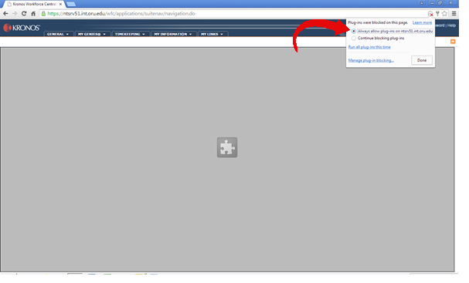

Additionally, you may receive the Internet Explorer and Firefox Java prompts from the previous page.

First-time Log-in

Usernames and passwords in Kronos are NOT currently synchronized with Novell. Your default username AND password are both initially set as the first letter of your first name, followed by your last name. For example, James Smith’s user name AND password would be “jsmith” (all lowercase).

You will be immediately asked to change your password. Follow the instructions on the screen to complete the password change. Once you have changed your password, you will see your default Kronos window, the “Timestamp” screen.

How to Log In:

- Double click on the KRONOS icon.
- Type in your user name and password and press the Log On button.

Editing Timecards:
Edits to entries in timecards should ONLY be performed to correct errors. Examples of errors include Missing Punches, Inadvertent Punches, Work Related Errands or Transposed Punches. Do not make adjustments to existing punches otherwise. Actual time worked (as recorded by the employee) should be reflected on the timecard, not the employees’ scheduled work time.

When Do I Add Comments?:
Comments are necessary for documentation purposes. All edits to timecards must have a comment. Please attach a comment to EVERY edit you make. (See instructions on page 4.)

- Approved Early Out/Late In - Child
- Approved Early Out/Late In - Family Emergency
- Approved Early Out/Late in - Other
- Approved - In/Out Transposed by Kronos
- Approved Work Outside Dept.
- Employee Forgot to Punch In or Out
- FMLA
- GPS data collected from the phone >> N/A, not used<<
- Kronos System Unavailable
- Lost Badge or Badge Defective
- Required Class/Seminar for Job
- Reserved>>HR or Payroll use only<<
- Shift Schedule Conflict with Clocked Time Entry>>N/A, not used<<
- Special Circumstances Approved by HR
- Unapproved Absence - No Call No Show
- Unapproved Early Out/Late In - Child
- Unapproved Early Out/Late In - Family Emergency
- Unapproved Early Out/Late In - Other
- Unintentional-Inadvertent Clock In or Out
- Workers Comp Dr’s Appointment
- Work-Related Errands

Pay Codes Used by Supervisors:
Pay Codes are used for hours other than regular hours worked, such as vacation, sick time, etc. See the list of Pay Codes below.

Pay Codes (when eligible): | Description
CRL - Critical Illness Leave | Submit Time OFF Slip (up to 3 days) with Doctor’s note to Payroll Department. Applies to employee or immediate family member who is critically ill or injured.
REG - Regular Hours | System generated.
FUN - Funeral | For immediate family only. Submit Time Off slip with a copy of obituary or church program to Payroll Department (up to 3 days in state, up to 5 days for out of state).
JUR - Jury Duty | Submit copy of summons to Payroll Department.
LNP - Leave No Pay | May be used when benefit time has been depleted. May also be used as in a suspension. In the case of a suspension contact Human Resources.
MIL - Military Leave | Submit copies of orders to Payroll Department. Complete and submit a Change of Status form.
PDW - Paid Doctor’s Worker’s Comp. Code | If the employee has a release to return to work and submits a treatment plan requiring said treatment during normally scheduled work hours, ORU will provide up to 2 hours of compensation. The employee will need to provide proof of the appointment from the doctor’s office or facility (i.e., physical therapy or follow-up doctor’s visit.) The employee’s time card should reflect the pay code of PDW for up to 2 hours per day. Any additional time away from work may be coded as sick leave, vacation, and/or leave without pay, depending on the employee’s preference.
SHF - Shift Differential | This is calculated automatically based on employee’s position.
SIC - Sick Leave | Used only when employee is sick, not a member of the family.
STD - Short Term Disability | 7 or 30 Day Wait period. Employee must contact the Benefits Dept.
TRM - Termination | 1 hour, Employee is no longer working. Submit Termination Form to Human Resources. (This does not generate pay.)
UNX - Unexcused absence/tardy | To be used when an employee is late to work or has an unexcused absence. Employee will not be paid for this time input
VAC - Vacation Accruals | Must use all vacation accruals prior to a leave no pay status.
WCC = Worker’s Compensation Code | Used beginning on first day of incident and until employee returns. Input # of hours absent per day. This code does not generate pay, but tracks hours.

Continue to submit Time-Off Authorization Slips to Payroll for events as they occur noting the hours and/or minutes.

If employee is lacking benefit hours to cover absence, insert the appropriate pay code and number of hour’s available (see accruals tab). For example, employee has only 6.5 hours vacation available and takes 8 hours. Insert the Vacation pay code with the amount of 6 hours and 30 minutes. Insert LNP (leave no pay) with 1 hour and 30 minutes. All vacation accruals need to be utilized prior to a leave no pay status.

All benefit hours must have appropriate documentation submitted to the Payroll Department by Monday “signoff” in order for employee to be paid on the upcoming payday.

Employees’ pay-stub will reflect vacation and sick leave in hours and hundredths. KRONOS is in hours and minutes and is converted to hundredths automatically.

Time Omissions after Approval or Sign-off:
After the approval and signoff procedures have been completed, any additional hours needing to be paid (i.e. employee forgot to clock in and out for the day) must be edited manually by the Payroll Dept. Please submit those hours to Payroll on a memo with the employee signature as well as the supervisor’s. The hours will be paid on the next payday.

How-To Instructions:

How to check for missed punches:
- Log into the KRONOS Timekeeper system.
- Reconcile Timecard window is set to Current Pay Period. Make sure it is on the desired pay period.
- Check for missed punches in the Missed Punch column.

How to open a time card:
- Double click on the employee’s name and their timecard will appear.

How to insert a punch:
All edits must include a comment.
- To insert a punch click once in the cell.
- Type in the time using the following format:
*Colons are optional. Ex: 800 is converted to 8:00.
*Enter AM for all times entered from 12:00am to 11:59am.
*Enter PM for all times entered from 12:00pm to 12:59pm.
*Leading and trailing zeros are optional. Ex: 0800 is converted to 8:00 and 8 is converted to 8:00.
- Right click within the cell and choose add comment.
- Select appropriate comment; add more information in Note section if needed. DO NOT include medical related information.
- Select “OK”.
- Click the Save button.

How to delete a punch:
- Click once in the cell.
- Press the Delete key on the keyboard.
- Click the Save button.

How to add a comment:
- Right click in the cell and choose Add Comment.
- Select the correct comment and press the OK button.
- Ensure the comment appears on the Comment tab below the timecard area.
- Click the Save button.

How to delete a comment:
- Click once on the Comment tab below the timecard area.
- Right click on the comment and choose Delete.
- Click the Save button.

How to add a Pay Code (vacation, sick, etc.):
- If a punch already exists for the day click once on the “bendy” arrow to the left of the date to create a blank, new line.
- Click in the cell in the Pay Code column.
- Click on the down arrow to select the correct pay code. See Pay Code list from pages 1-2. Press the Tab key.
- Enter the number of hours using the following format:
*Enter time in hours and minutes. Ex: 5 ½ should be entered as 5:30 or 5.30.
*Colons are necessary. Ex: 530 will not convert to 5:30 but to 530 hours.
*Leading zeros are optional.
*Do not use trailing zeros.
- Click the Save button.

How to approve timecards:
- If not already done so, log into the KRONOS Timekeeper System.
- Reconcile Timecard window is set to Current Pay Period. Change it to Previous Pay Period.
- Ensure no checkmarks are in the Missed Punch column.
If checkmarks are showing, click on the Refresh button in the header.
If the checkmarks do not disappear then double click on the person’s name and correct the missed punch.
- Select Actions from the menu bar and choose Select All.
- Select Approvals from the menu bar and choose Approve OR Timecard Managers: select Sign off from the Approvals menu bar.

FOR ADDITIONAL INFORMATION, please contact the Human Resources Department at extension 7163.

