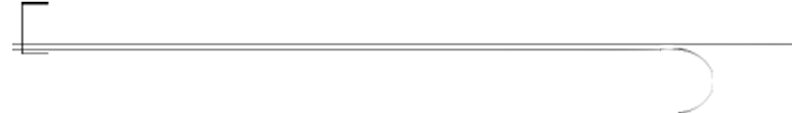

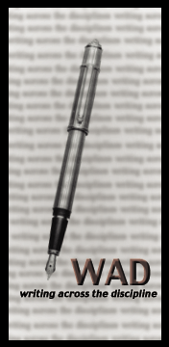
Writing Across the Disciplines Newsletter
Spring 2002
Get to Know the Writing Across the Disciplines Committee
Major initiatives in writing across the disciplines continue at ORU in part through the work of the Writing Across the Disciplines Committee comprised of representatives from each school and the administration. The following members currently serve on the committee. Feel free to contact them with concerns, questions, suggestions, or agenda items you would like considered at WAD committee meetings.

Arts and Sciences
LeighAnne Locke (Math and Computer Science) x 6697
Nathan Opp (Art) x 6212
Don Vance (Undergraduate Theology) x 6106
Ken Weed (Chemistry) x 6917
Business
Chuck Atkins (Undergraduate Business) x 6560
Education
Jean Mosley x 6043
Nursing
Laurie Doerner x 6146
Administration
Dean of Instruction: Deborah Sowell x 6703
Associate Dean, School of Arts and Sciences: Dave Connor x 6214
Director of Institutional Research: Cal Easterling x 6538
Chair
Lori Kanitz (English) x 6064

Don’t Have Time to Grade? Try the “One-Minute Paper”
In “What Students Want,” an article by Tim Goral in the October 2001 issue of Matrix, Richard Light, author of Making the Most of College: Students Speak Their Minds, suggests professors use the “One-Minute Paper” as a way to reinforce main points and get feedback instantly about what students have learned that day. Originating with Patricia Cross, a professor emeritus at the University of California, Berkley, the assignment calls for professors to set aside the last two minutes of a class period during which they ask students to write short answers to the following two questions:
1. “What was the main idea you learned in class today?”
2. “What is the main unanswered question you leave class with today? What is the ‘muddiest’ point?”
Light notes, “Some experienced professors comment that it is the best example of
high payoff for a tiny investment they have seen in years of teaching.”
Untangling the Web: Resources to Help Students Use the Internet Effectively

For most students, the World Wide Web is the first “stop” in the quest for information for written assignments. Unfortunately, not all sites are reliable, and many college students lack the knowledge or skill to evaluate web resources. The two sites below provide excellent information instructors can use to educate students about using web resources wisely and ethically.
“A Student’s Guide to Research with the WWW” can be found at http://www.slu.edu/departments/english/research/. It includes instructional material on search strategies, evaluating web pages, recognizing different types of web pages, and citing online sources.
“Evaluating Web Resources” can be found at http://www2.widener.edu/
Wolfgram-Memorial-Library/webevaluation/webeval.htm. It includes PowerPoint presentations that instructors can use, materials for students on types of web pages, criteria for evaluating web sources, an excellent bibliography, and a list of links to other related sites.

Results of Spring 2001 Senior Paper Writing Surveys Compiled
Twenty-two faculty members who teach senior paper responded to this survey. However, five had to be discarded leaving seventeen. The survey asked the following question: What do you feel is the greatest weakness in the writing ability of ORU’s undergraduates in your senior paper sections? Please prioritize the following list by placing a number on each blank: ( 1= worst problem area, 2= second worst problem area, etc.).

Summary

Responses | Priority  2001 | Priority 2000
A. ability to write clear prose (language is wordy, abstract, etc.) | 1 | 3
B. ability to develop an idea fully in writing | 3 | 2
C. persistent errors in grammar and word usage | 2 | 1
D. ability to construct an organized paper | 4 | 4
E. ability to use sources appropriately | 5 | 5
F. unethical use of sources | 6 | 7
G. weak vocabulary (discipline specific) | 7 | 6

