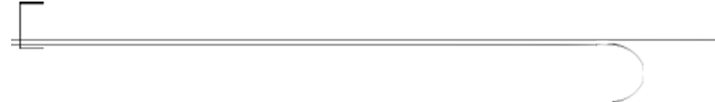

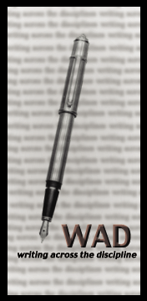
Writing Across the Disciplines Newsletter
Fall 2002
WAD Award Winner Demonstrates Excellence in Teaching with Writing
In spring 2002, the Writing Across the Disciplines Committee introduced the Writing Across the Disciplines Award for Excellence inspired by alumna Phyllis Shelton-Pomakoy. The winner of the 2002 award is Robert Chapman, Undergraduate Business. Mr. Chapman has been a member of the business faculty since 2000, teaching financial management, advanced tax accounting, and auditing. He uses various types of writing assignments in all three courses to help students learn course material, demonstrate mastery of it, and become competent business writers.
For example, students in his financial management course prepare a weekly summary of an article selected from Barron’s, a business and financial periodical. The summary is evaluated on its accuracy, the student’s ability to relate the article to a financial management topic discussed in class, and its technical correctness. Students also write two critical analysis papers in response to reading for the course. They are asked to provide a “comprehensive written evaluation of the author’s position relative to the student’s position on the same topic” and then effectively defend their evaluation. He uses similar assignments in his advanced tax accounting and auditing courses.
Mr. Chapman notes that the writing assignments, particularly the weekly summaries, cause students to begin discussing course material and asking questions about it. The writing leads to synthesis, critical analysis, and further inquiry by students. “They also,” Mr. Chapman adds, “just like the practice. They like having to write the sorts of things they will be writing in their professions.”
One of the more meaningful assignments Mr. Chapman has created is the “Whole Man Memorandum” opportunity in which he asks students to submit weekly reports (12 total) discussing their spiritual, mental, and physical development. Students identify specific development activities undertaken in each of the three areas, the benefits derived from them, and the perceived changes required by the activities.
Chapman reports that “students really appreciate the opportunity to reflect on and express the changes they have undergone during the course of the semester. I’ve had many students comment on how glad they were to have been asked to think about these things. They look back and can see how they have grown.”
The Writing Across the Disciplines Committee is pleased to recognize Mr. Chapman’s outstanding integration of writing and learning with ORU’s mission.

Plagiarism in Student Writing: An Increasing Problem
According to the November 13, 1999, U. S. News & World Report article, “Exclusive Poll: Cheaters Win,” its 1999 poll indicates 80% of high-achieving students admit they have cheated, and 95% of them claim never to have been caught. Half of those who cheated say cheating is not necessarily wrong. Furthermore, Duke’s

Plagiarism in Student Writing (continued)
Center for Academic Integrity reports 75% of college students admit to cheating.
Of course, students have always cheated, but “[w]hat’s changed, experts maintain, is the scope of the problem: the technology that opens new avenues to cheat, students’ boldness in using it, and the erosion of conscience at every level of education” (Kleiner and Lord qtd. in “Exclusive Poll” n. p.).
How can instructors meet the challenge of detecting ever more sophisticated ways of plagiarizing? The following are helpful suggestions:*
- Understand why students cheat (time pressure, fear of failure, the thrill of it, etc.)
- Educate yourself about what they may try to do (purchase a paper through a paper mill, cut and paste from a web site, etc.)
- Educate your students about plagiarism to help them avoid “crimes of ignorance.”
- Learn to recognize the clues of plagiarized writing (anachronisms, mixed writing styles, web site addresses at the bottom of the paper, etc.)
- Become acquainted with sources of plagiarized works (paper mills, “how-to-cheat” web sites, etc.)
- Search on-line for strings of plagiarized text using a search engine like Google.
Most experts agree that prevention is better than cure; no one wants to deal with the messy and often hard-to-prove issues once plagiarism has occurred. Learn how to build plagiarism-resistant assignments to reduce the chances of it occurring in the first place. To learn more about detecting and preventing plagiarism, sign up for the next WAD faculty workshop on “Tips for Detecting and Preventing Plagiarism in Student Writing” or investigate these recommended on-line resources:
- “Anti-Plagiarism Strategies for Research Papers” http://www.virtualsalt.com/antiplag.htm
- “Plagiarism” (Downer’s Grove North High School Library) http://www.csd99.k12.il.us/north/library/plagiarism.htm
- “Plagiarism Prevention” (University of Wisconsin-Platteville site) http://www.uwplatt.edu/~library/reference/plagiarism.htmlx
*From “Anti-Plagiarism Strategies for Research Papers,” http://www.virtualsalt.com/
antiplag.htm.

English 112 Lab: A Writing Refresher Course for all ORU Students
Did you know your students can take a lab course in writing basics? Each semester, the English Department offers several sections of English 112 lab, a refresher writing course open to all ORU students. Class sizes are small, usually between six and twelve students, to allow for individualized instruction. At the beginning of the course, students take a diagnostic test to determine skill weaknesses. They are then assigned appropriate skills exercises by their instructor, a member of the English Department faculty. The course is a one-hour credit, pass/fail course with no homework. If you have students who need the course, encourage them to enroll. You can then request that individual students work with the faculty tutor on specific skills areas or even work on specific writing assignments for your class during the lab time.

