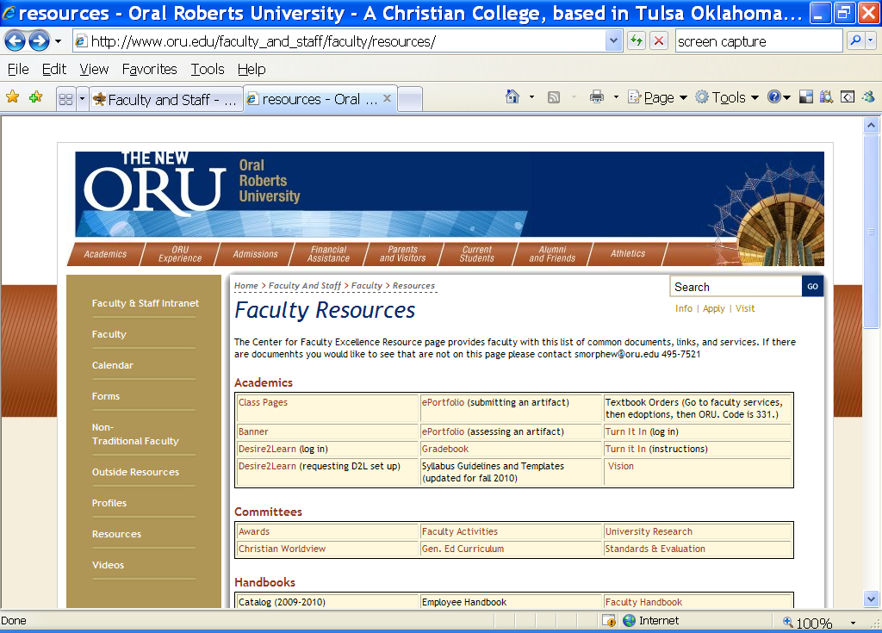
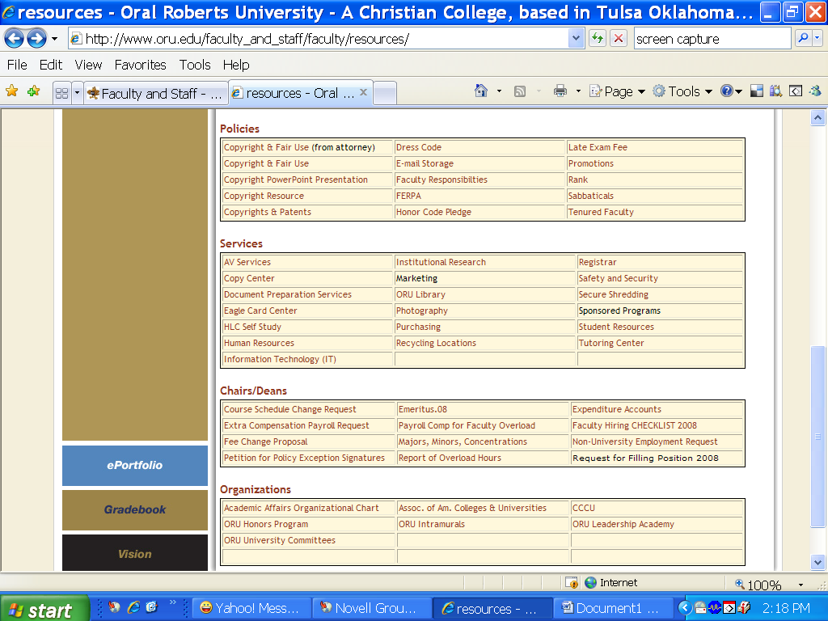
Insert forms (add to grid underneath Tenured Faculty):
*Peer Rating (Promo/Ten)
*Observer’s Rating Form A
*Observer’s Rating Form B
*Observer’s Form C
Insert forms (see below)

Eland notes, Oct 31, 2010:
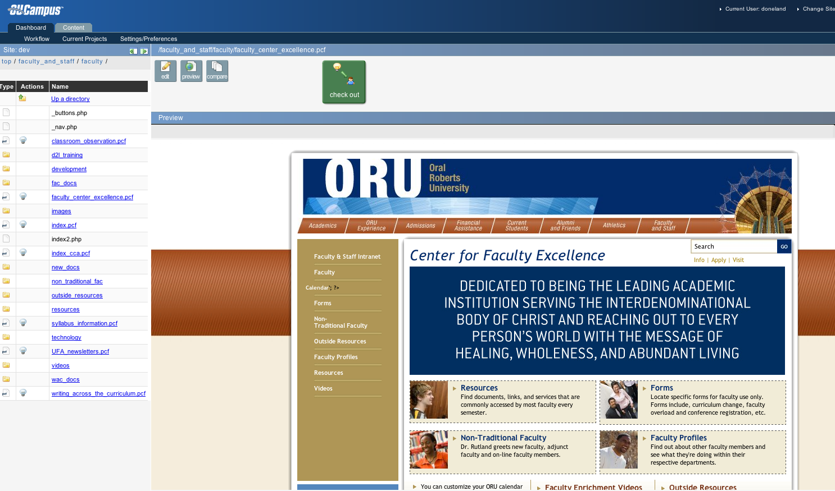

Eland notes:

