

Oral Roberts University

MUSIC DEPARTMENT

Whole Person Assessment Handbook
(ePortfolio)

2010-2011

Table of Contents

Oral Roberts University Mission statement 1

Oral Roberts University Music Department Mission statement 1

Oral Roberts University Whole Person Assessment statement 1

Oral Roberts University Music Department Whole Person Assessment statement 1

Setting up your ePortfolio 2
General Education Portfolio 2
Major Portfolio 2

Submitting an Artifact in ePortfolio 3

ePortfolio Web Support 4

Does it matter what I name m artifact in m Artifact Library? 4
Why can’t I upload documents saved in Microsoft Works or WordPerfect? 4
What should I do if I am not receiving ePortfolio emails? 4
What are the steps for uploading an artifact and sending it for assessment? 5
Where can I go if I need to scan an artifact and do not have a scanner? 5
How do I know where to place my artifact in my ePortfolio? 5
What should I do if I have several artifacts from different classes that need to occupy the same space in my ePortfolio? 7
If I want to send my ePortfolio to my professor for assessment, but the “submit assessment” link is missing, what do I do? 7
What if I do not know my professor’s name? 7
How can I find out my professor’s assessment of my artifact? 7
Can I remove an artifact from ePortfolio once I have successfully submitted it for assessment? 7
What should I do when I think I uploaded my artifact correctly but received communication from ORU that something with my ePortfolio was incomplete? 8
Where can I go to get ePortfolio help? 8
Whom should I contact if I have lost or forgotten my user name/password? 8

Music Department ePortfolio Timeline 9

Freshman year artifacts 9
Sophomore year artifacts 10
Junior year artifacts 11
Senior year artifacts 12

Faculty Assessment of Student Artifacts 13

Appendix I........................................................................................................................................ 15
Music Department ePortfolio timeline worksheet 15-17

Oral Roberts University Mission Statement

The mission of Oral Roberts University – in its commitment to the Christian faith – is to educate the whole person in spirit, mind, and body, thereby preparing its graduates to be professionally competent servant-leaders who are spiritually alive, intellectually alert, physically disciplined, and socially adept. The University seeks to synthesize the best practices of liberal arts, professional, and graduate education with a charismatic emphasis to enable students to go into every person’s world with God’s message of salvation and healing for the totality of human need.

Oral Roberts University Music Department Mission Statement

Within a Christian, charismatic environment, the primary mission of the Music Department is to provide students with an excellent undergraduate foundation in music, as well as a strong emphasis on music’s past, present and future prospects. In this context, the general purposes of the department are (1) to provide opportunities for students to develop their music capabilities and interests through the use of music as a socializing force, as an aid to compassionate understanding of themselves and their environment and as an avenue of self-expression; (2) to stimulate an appreciation and love for music through the study of its various disciplines: (3) to develop techniques for mature evaluation of musical standards; (4) to give an adequate background for further study in graduate school; (5) to cultivate tools for teaching in public and private schools, teaching in private studios, performing in professional music organizations and working in related music fields; and (6) to prepare for various church ministries as well as the Oral Roberts ministries.

Oral Roberts University Whole Person Assessment statement

Whole Person Assessment is a university-wide initiative to assess student outcomes in General Education and in a student’s major. Oral Robert’s University seeks to graduate students that are Spiritually Alive, Intellectually Alert, Physically Disciplined and Socially Adept. These General Education outcomes are measured objectively through the Whole Person Assessment Artifacts (work) that students are required to complete in class. Additionally, competencies and outcomes required for individual majors and subject areas are also measured through the use of Whole Person Assessment. Data collected from student work in their major is used for program evaluation, change and accreditation reports.

Students that are freshman at ORU will set up their General Education Whole Person Assessment. Students will also create another portfolio reflecting the competencies and outcomes required for their major.

Oral Roberts University Music Department

Whole Person Assessment statement

The Music Department Whole Person Assessment (WPA) Handbook is designed to clarify the requirements of the Music Department. All majors within the Music Department require the same WPA artifacts with few exceptions. The Whole Person Assessment Timeline explains and arranges the requirements according to the student’s year within their chosen Music degree program. All Music degree artifacts are to be completed three weeks prior to the last week of classes during the students last semester. Some artifacts consist of a Final Exam for a course in which the artifact will not need to be uploaded by the music student.

A completed Music Department portfolio will demonstrate the completion of departmental and National Association of Schools of Music (NASM) requirements. Other portfolios may be created to assist in developing an on-line professional portfolio relative to additional disciplines, graduate school admission, or employment opportunities.

Setting up your ePortfolio

IMPORTANT NOTE: The instructions on this page will help you set up your ePortfolio the first time you access it. You will only need to do the steps on this first page once.
General Education ePortfolio
- Open Internet Explorer, and go to http://eportfolio.oru.edu.
- Click on the “LOG-IN” link on the sidebar.
- Under “EXISTING SUBSCRIBERS,” type your user id (Z-number, including the “Z”) and password (“neptune” until you change it), then click on the “LOGIN” button.
- If this is your first time to log in, you will need to acknowledge your acceptance of the terms of use before you can proceed.
- Click on the “MY PORTFOLIOS” tab.
- Under “DEPARTMENT LIST,” click the box to “SHOW ALL DEPARTMENTS.”
- Click “JOIN” to join GENERAL EDUCATION.
- Scroll down and click the button to “ADD NEW PORTFOLIO.”
- Under the TABLE OF CONTENTS drop-down menu, select “GENERAL EDUCATION OUTCOMES.”
- Select the theme that you would like for this portfolio.
- Click on the “SAVE” button.
- Click on the link to “RETURN TO MY PORTFOLIOS.”
CONGRATULATIONS! You have successfully set up your General Education ePortfolio.
If you already know your major, please follow the steps below.
Major ePortfolio
- Make sure that you are on the “MY PORTFOLIOS” tab.
- Under “DEPARTMENT LIST,” click the box to “SHOW ALL DEPARTMENTS.”
- Find your major department, and click “JOIN.”
- Scroll down and click the button to “ADD NEW PORTFOLIO.”
- Under the TABLE OF CONTENTS drop-down menu, select your major.
- Select the theme that you would like for this portfolio.
- Click on the “SAVE” button.
CONGRATULATIONS! You have successfully set up your Major ePortfolio

Submitting an Artifact in ePortfolio (WPA)
Logging In
- Open Internet Explorer, and go to http://eportfolio.oru.edu.
- Click on the “LOG-IN” link on the sidebar.
- Under “EXISTING SUBSCRIBERS,” type your user id and your password and then click on the “LOGIN” button.
- Click on the “MY PORTFOLIOS” tab.
- Find the “ACTIONS” menu next to the portfolio that you wish to modify, click on it, and select “EDIT.”
Submitting the Artifact through your ePortfolio
Pay careful attention to where the artifact belongs. For example, the Honor Code Reflection Paper (Entry Level) is listed under “Spiritually Alive,” then “Ethical Behavior,” and then “Honor Code Reflection Paper (Entry Level) (GEN 099).”

- Click on the main level where your artifact belongs. (For example, the Honor Code Reflection Paper goes under the main level of “SPIRITUALLY ALIVE.”)
- Click on the sublevel where your artifact belongs. (For example, the Honor Code Reflection Paper goes under the sublevel of “ETHICAL BEHAVIOR.”)
- If you are using your General Education portfolio, you will need to click on link for the specific assignment that you are uploading. (For example, for the Honor Code Reflection Paper, you would click on “HONOR CODE REFLECTION PAPER (ENTRY LEVEL) (GEN 099).” (It is ESSENTIAL that you place your artifact in the correct location. If you place an artifact in the wrong section or subsection of your ePortfolio, your professor will not be able to assess your artifact.) If you are using your major portfolio, you may or may not need to click to a third level of the portfolio. Consult with your major department or ePortfolio Help Desk staff if you are not sure.
- At the top of the page, click “ADD CONTENT.”
- Scroll down to “ARTIFACT” and click the + sign next to it.
- Click on the “BROWSE” button (“CHOOSE FILE” on Macs). A dialog box will open. Find the item you want to upload and select it by double-clicking on it or by clicking on it once and choosing OPEN in the dialog box.
- Click the “UPLOAD” button.
- Go to the top of the page and click on the “SAVE” button.
- Make sure that your paper appears on the ePortfolio page and that you can open it.
- Click on the “SUBMIT PAGE” button to submit the page to your instructor.
- In the box, begin typing the name of your instructor.
- Click on the correct name of your instructor.
- Click the “SUBMIT” button.
- You should see a message verifying that your artifact was submitted successfully.
CONGRATULATIONS! You have successfully uploaded and submitted an artifact! If you need assistance with an ePortfolio-related issue, please contact the ePortfolio Help Desk (eportfolio@oru.edu or x7356).

ePortfolio Web Support

For tutorials, instructions, frequently asked questions, and more, visit www.oru.edu, click on “Current Students,” and then click on “My Academics” and find and click the link called “Whole Person Assessment.” You will particularly want to check out “Instructions,” where you can find directions on how to complete all of the tasks required for ePortfolio. The Music Department Handbook and other handbooks and resources related to Whole Person Assessment can be found on this site.

One of the most important documents you can access online is the “General Education ePortfolio Artifact Checklist,” which lists every required artifact for the General Education ePortfolio and where it should be placed in your ePortfolio. Once you have entered the “ePortfolio” website, click on “GEN 099 Class Handouts,” and then click on either the PDF or HTML form of the “Master Checklist.”

Does it matter what I name my artifact in my Artifact Library?

Currently, the ePortfolio default setting is to give your artifact the name of your document file with X’s between the words. (For instance, if your file is named “Honor Code Reflection Paper.doc,” it will be given the name of “(HonorXCodeXReflectionXPaper.doc)” in your Artifact Library unless you rename it. We suggest that you name each artifact clearly so that your professor will be able to distinguish it from other artifacts that are in the same ePortfolio sub-folder.

Why can’t I upload documents saved in Microsoft Works or WordPerfect?

Artifacts must be uploaded in a format that professors can open and read. ORU’s computer network is equipped with Microsoft Office. Thus, documents saved in Works or WordPerfect often do not open or become jumbled when opened in Word. Appropriate file types are as follows: HTML, PDF, Word.

What should I do if I’m not receiving ePortfolio emails?

Log in to Chalk & Wire. Your contact information should be listed on the first page. Check your email address. If there is a typo in it, or if it is an out-dated email address, click on the link named “click here to change details.” Here you will be able to insert your correct contact information. If your contact information is correctly listed, double check your bulk mail settings to make sure your account will let you receive emails from ePortfolio@oru.edu. If you still cannot receive emails from ePortfolio, contact the ePortfolio Help Line (ePortfolio@oru.edu or 918-495-7356).

What are the steps for uploading an artifact and sending it for assessment?

There are three main steps in the process. First, the artifact must be uploaded to the Artifact Library. Second, the artifact must be placed in the correct location in the ePortfolio. Third, the artifact must be sent to the professor for assessment. For step-by-step instructions on this process, consult “Instructions for Students Using ePortfolio” on pp. 23-25 of the General Education Handbook.

Where can I go if I need to scan an artifact and don’t have a scanner?

• The 2nd Floor (GC) Academic Computing Lab is open 8:00 a.m. to 10:30 p.m. most days. There are 8 dedicated computers and scanners, and the staff members are helpful.
• ALSC office (3rd Floor, LRC, next to the Java Stop)—Ask for Dr. Gweth Holzmann or Jana Swartwood.
• Ask a fellow student if you can use his or her scanner. Avoid saving scanned items as TIFF files. The best practice is to save the scans as JPEGs and then save the JPEG pictures into a Word file.

How do I know where in my ePortfolio to place my artifact?

It is very important that you upload your artifact into the correct place in your ePortfolio. Each artifact is connected to a certain proficiency/capacity. Consult the “General Education ePortfolio Artifact Checklist” on pp. 39-42 of the General Education Handbook or the individual artifact description in this handbook. Be sure you know the correct proficiency for your artifact before you upload it. In your ePortfolio, your artifact should go in the section named for that proficiency. For instance, if you are uploading the Honor Code Reflection Paper (Freshman), you will choose the folder labeled “Spiritually Alive” and then place the artifact in the sub-folder labeled “Ethical Behavior.”

There are two steps to consider when submitting your artifact for assessment. First, you will come to a page that asks you to click in a box that matches the artifact’s designated proficiency. See the graphic on the next page.

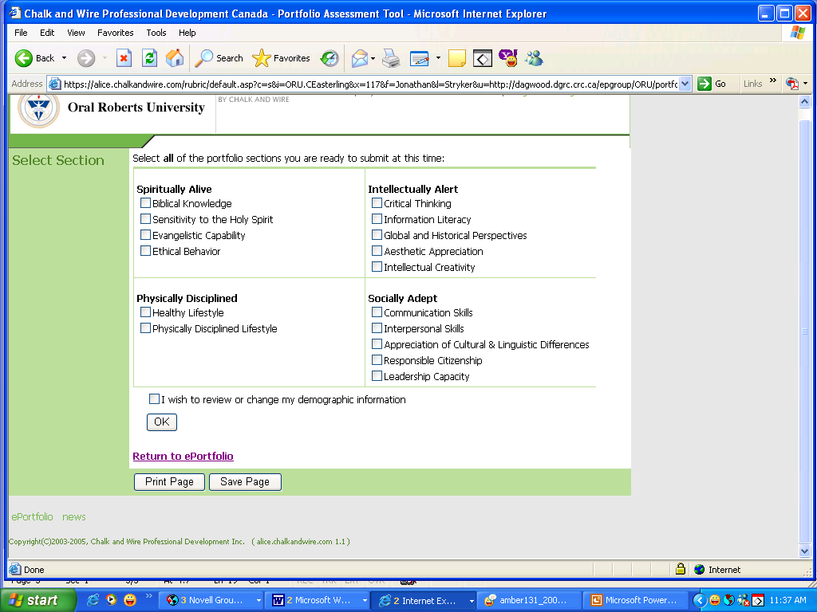

Second, you will need to select the rubric that goes with your artifact. Look at all the options carefully before selecting your rubric; if you choose the wrong rubric, your professor will not be able to assess your artifact. See below.

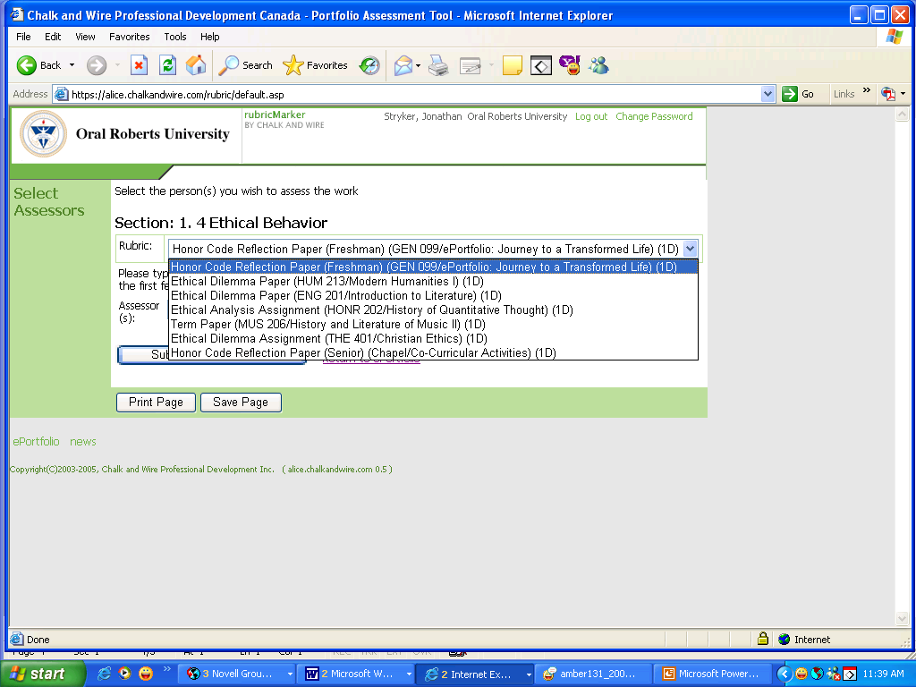

What should I do if I have several artifacts from different classes that need to occupy the same space in my ePortfolio (for instance, Evangelistic Capability)?

Keep all artifacts in your ePortfolio. Do not delete an artifact unless you are fixing a problem and resubmitting the artifact. You will ultimately end up with several artifacts in a given space. For instance, in the Evangelistic Capability sub-folder, you will end up with two Old Testament artifacts and a Charismatic Life artifact—and potentially Missions or Music Ministries artifacts as well. All appropriate artifacts must remain in the ePortfolio for the duration of your time at ORU.

I want to send my ePortfolio to my professor for assessment, but the “Assess” button is missing. What do I do?

Your ePortfolio is like any other website. You can work on it and change it all you like, but until you “publish” it, your changes will not be visible online. If the “Assess” button has disappeared, it means that you have made changes to your ePortfolio that have not been published. Once you publish your ePortfolio and return to where you started, the “Assess” button should reappear.

What if I don’t know my professor’s name?

Minimize the Internet window that has your ePortfolio open. Open a new Internet browser. Go to www.oru.edu, click on “Academics,” then click on “VISION: Enrollment and Registration System.” Log in to VISION, click “Student Services and Financial Aid,” click “Registration,” click “Student Detail Schedule,” and choose the correct term. You should then see your entire schedule including your professor’s name. When you have obtained the necessary information, log out of VISION, maximize the Internet browser with your ePortfolio, and continue the artifact submission process. [If you are submitting your artifact to a TA, you should follow the instructions given to you in your discussion group. Most TAs share generic Chalk & Wire accounts (for example, “1 CharismaticLife” or “2 BibLit”).]

How can I find out my professor’s assessment of my artifact?

Once you have submitted your artifact for assessment, you can click on the “Check Assessment” button on the main ePortfolio page (the page where you went to edit and submit your artifact). There you will see a listing of all artifacts that you have submitted for assessment. Once a professor completes the assessment, you will see a colorful bar graph delineating your score. In addition, you can view comments, if the professor has chosen to post comments.

Can I remove an artifact from my ePortfolio once I have successfully submitted it for assessment?

You should not remove an artifact from your ePortfolio unless (a) you are replacing it with a corrected version of the same document, (b) you have uploaded it in the wrong place and are correcting the error, or (c) you are deleting multiple versions of the same artifact. Your artifacts should remain in your ePortfolio for the duration of your time at ORU. If you remove them, then faculty will not be able to view them, and this may cause problems when your ePortfolio is audited at the end of a semester and prior to graduation.

What should I do when I think I uploaded my artifact correctly but I received communication from ORU that something with my ePortfolio was incomplete?

Follow the directions given in the letter/email/voice message that you received. If you are instructed to contact a specific individual, please do it as soon as you get the message. You are also welcome to contact the individuals monitoring the ePortfolio Help Line at 495-7356 (x7356 on campus) or ePortfolio@oru.edu and ask them to check your status in the Chalk & Wire system. Sometimes there is a problem with your actual ePortfolio account, and in these cases we need to fix it to avoid future problems. Other times, you may have inadvertently missed a step in the process. Often these things can be cleared up quickly and easily.

Where can I go to get ePortfolio help?

- ePortfolio Help Line at x7356 (918-495-7356) or ePortfolio@oru.edu
- 2nd Floor (GC) Academic Computing Lab, 8:00 a.m. to 10:30 p.m. most days
- ALSC office (3rd Floor, LRC, next to the Java Stop)—Ask for Dr. Gweth Holzmann or Jana Swartwood.
- ePortfolio Subadministrator in your major department
- Website: www.ePortfolio.oru.edu (many helpful resources)
- Your APA or ADD
- ePortfolio Help Nights (dates and times vary)

Whom should I contact if I have lost or forgotten my user name/password?

If you have lost or forgotten your user name or password, you can contact the ePortfolio Help Line (ePortfolio@oru.edu or 918-495-7356), visit Steve Duclos in the GC 2nd Floor Academic Computing Lab, or visit the School of LifeLong Education/Adult Learning Service Center on the 3rd floor of the LRC next to the Java Stop.

Music Department ePortfolio Timeline

Freshman Year Artifacts

2.1A Sight Singing II Final Exam

All students enrolled in Sight Singing II (MUS 104) will take the sight-singing final exam. The results of the exam will be scored and assessed manually by their MUS 104 instructor. Students will not upload any artifacts related to this exam.

2.1B Ear Training II Final Exam

All students enrolled Ear Training II (MUS 104) will take the ear-training final exam. The exam will be scored and assessed manually by their MUS 104 instructor. Students will not upload any artifacts related to this exam.

2.5B Original Composition

All students enrolled Harmony II (MUS 102) will create an original composition for Harmony II (MUS 102). MUS 102 instructors assess student compositions based on rubrics for Melody, Rhythm, Harmonic Progression, Formal Structure and Creativity. Compositions will be scored and assessed manually by their MUS 104 instructor. Students will not upload any artifacts related to this assignment.

3.1A Harmony II Final Exam

All students enrolled Harmony II (MUS 102) will take the harmony final exam. The exam will be scored and assessed manually by their MUS 104 instructor. Students will not upload any artifacts related to this exam.

2.7A Self-Assessment of Seminar Performance Upload/Send Form

All Freshman are required to sing or play in Music Seminar (MUS 099) during the Spring or Fall Semester. A seminar date will be set at the beginning of each semester so students can anticipate and prepare for their performance. Each performance will be recorded so students can complete the self-assessment form. The self-assessment will be uploaded to the student’s portfolio and sent to their applied teacher for ePortfolio assessment.

4.1A Notation Example Final Project Upload/Send Assignment

Students enrolled in the Introduction to Music Technology (MUS 105) class will complete an assignment to demonstrate competence using notation software. The notation example will be uploaded to the student’s portfolio and sent to their Music Technology instructor for ePortfolio assessment. The instructor will determine completion and upload dates.

4.1B Audio/Recording Project Upload/Send Assignment

Students enrolled in the Introduction to Music Technology (MUS 105) class will complete an assignment to demonstrate competence in audio recording. The audio recording assignment will be uploaded to the student’s portfolio and sent to their Music Technology instructor for ePortfolio assessment. The instructor will determine completion and upload dates.

Sophomore Year Artifacts

2.1C Sight Singing IV Final Exam

All students enrolled in Sight Singing II (MUS 202) must take the sight-singing final exam. The exam will be scored and assessed manually by their MUS 202 instructor. Students will not upload any artifacts related to this exam.

3.1B Harmony IV Final Exam

All students enrolled in Harmony II (MUS 202) must take the harmony final exam. The exam will be scored and assessed manually by their MUS 202 instructor. Students will not upload any artifacts related to this exam.

2.2B Barrier Exam Performance Proficiency Upload/Send Form

All music majors enrolled in private Applied Lessons (MUS 026-051) during their sophomore year must perform a jury for the instrumental or vocal faculty at the end of the spring semester. During this jury students will be evaluated on a variety of criteria to determine their continuation of study and/or the possibility of performing a Junior Recital. Upon the completion of the jury, students will upload the form into the their portfolio and send it to their applied teacher for ePortfolio assessment.

3.1C Music History Exam with Listening Examples

At the completion of the History and Literacy of Music I (MUS 205), and II (MUS 206) sequence, students must take the Music History Barrier Exam. This exam will demonstrate the students’ basic knowledge of Western Music History in the areas of Polyphony, Opera, Symphonic Music, Piano and Vocal genres as well as of Early and Late 20th Century Music. The Musicology instructor will post dates and times for this exam. Students will be notified of their score on the exam. Students will not upload any artifacts related to this exam.

2.3A Keyboard Proficiency Exam

All music majors are required to successfully pass the Keyboard Proficiency (PRF 101) during the Sophomore year or during Class Piano IV. Successful completion of the Keyboard Proficiency is required for graduation. For further information concerning proficiency examinations, refer to the Department of Music Student Handbook. Students will not upload any artifacts related to this exam.

3.1D Music Vocabulary Proficiency Exam

All music majors are required to take and successfully pass the Music Vocabulary Exam (PRF 100) during the Sophomore year. A successful passing grade on the exam is required for graduation. The vocabulary exam is administrated twice each semester. A study guide can be obtained prior to the exam. For further information concerning proficiency examinations, refer to the Department of Music Student Handbook. Students will not upload any artifacts related to this exam.

Junior Year Artifacts

2.4B Junior Recital Performance Planning Upload/Send Form

All students performing a Junior Recital must complete the Performance Planning form found online at the ePortfolio link at WPA Instruction page online. The Planning form will be completed at the beginning of the semester of the student’s recital with the oversight of their applied teacher. The completed form will be checked during the student’s recital hearing. Upon successful completion of the hearing, students will upload the form into their portfolio and send it to their applied teacher for ePortfolio assessment.

3.2A Junior Recital Program Notes Upload/Send Form

All students performing a Junior Recital must complete the Program Notes form found online at the ePortfolio link at WPA Instruction page online. Students must demonstrate the ability to synthesize research and present it in a program notes format for the recital program. Students will research and record information on the form throughout the semester with the oversight of their applied teacher. The completed form will be checked during the student’s recital hearing. Upon successful completion of the hearing, students will upload the form into their portfolio and send it to their applied teacher for ePortfolio assessment.

3.3A Résumé Upload/Send Form

All students performing a Junior Recital must complete a resume demonstrating the literature they have studied in private lessons and ensembles. It is advised that students keep programs of performances to help in the completion of this artifact. The completed form will be checked during the student’s recital hearing. Upon successful completion of the hearing, students will upload the form into their portfolio and send it to their applied teacher for ePortfolio assessment.

Junior Recital Video Clip 2.2C Optional

Junior Recital Self-Assessment 2.7 Upload/Send Form

All students performing a Junior Recital must complete the Junior Recital Self-Assessment form. This form will be completed after the recital. It is recommended that the student obtain a copy of the recording of the performance, review the performance and then complete the form. This form can be found at the ePortfolio link at WPA Instruction page online. Upon the successful completion of the form, students will upload the form into their portfolio and send it to their applied teacher for ePortfolio assessment prior to the end of the semester or at a date specified by the applied teacher.

2.6 Conducting Final Exam

All students enrolled in Conducting I (MUS 333) must take a written Final exam as well as demonstrate competent basic conducting skills. This exam will assess students’ ability to conduct preparatory beats, beat patterns and releases. The written portion of the exam will assess students’ knowledge of conducting terms and related areas. The results of the exam will be scored and assessed manually in ePortfolio by the MUS 333 instructor. Students will not upload any artifacts related to this exam.

Senior Year Artifacts

2.4B Senior Recital Performance Planning Upload/Send Form

All students performing a Senior Recital (MUS 421) must complete the Performance Planning form found at the ePortfolio link at WPA Instruction page online. At the beginning of the recital semester, the Planning form must be completed with the oversight of the applied teacher. The completed form will be checked during the student’s recital hearing. Upon successful completion of the hearing, students will upload the form into their portfolio and send it to their applied teacher for ePortfolio assessment.

3.2A Senior Recital Program Notes Upload/Send Form

All students performing a Senior Recital must complete the Program Notes form found on the ePortfolio link at WPA Instruction page online. Students must demonstrate the ability to synthesize research and present it in a program notes format for their recital program. Students will research and record information on the form throughout the semester with the oversight of the applied teacher. The completed form will be checked during the student’s recital hearing. Upon successful completion of the hearing, students will upload the form into their portfolio and send it to their applied teacher for ePortfolio assessment.

3.3A Résumé Upload/Send Form

All students performing a Senior Recital must complete a resume of the literature they have studied in private lessons and ensembles. It is advised that students keep programs of performances to help in the completion of this artifact. The completed form will be checked during the student’s recital hearing. Upon successful completion of the hearing, students will upload the form into their portfolio and send it to their applied teacher for ePortfolio assessment.

2.2C Senior Recital Video Clip Optional

2.7 Senior Recital Self-Assessment Upload/Send Form

All students performing a Senior Recital must complete the Senior Recital Self-Assessment form. This form will be completed after the recital. It is recommended that the student obtain a copy of the recording of the performance, review the performance and then complete the form. This form can be obtained on the ePortfolio link at WPA Instruction page online. Upon the completion of the form, students will upload the form into their portfolio and send it to their applied teacher for ePortfolio assessment prior to the end of the semester or at a date specified by the applied teacher.

Senior Paper/Project Upload Form

All students enrolled in Senior Paper/Project (MUS 499) will meet with the project advisor for topic approval and review of the syllabus. The project must be completed within the determined deadlines. Students successfully completing the Senior Paper/Project will be given a completed Senior Paper/Project rubric scored by the advisor. Students will upload the completed rubric and an abstract of the senior paper.

Faculty Assessment of Student Artifacts

Assessing an Artifact (Faculty)

Open up Internet Explorer, and go to http://eportfolio.oru.edu.
Click the yellow sidebar link named “ENTER ePORTFOLIO.”
Type your user id and password in the appropriate locations. (If you are unsure of your user id, type in your full ORU email address. If you are unsure of your password, find the “Forgotten your password?” section and click on the link to reset it.)
Click “OK.”
Click on the icon for ePortfolio2 (at the bottom of the page).
If you are not already on the “MY ASSESSMENTS” page, click on the tab for “MY ASSESSMENTS.”
Under “STUDENTS WITH WORK FOR ASSESSMENT,” click on the name of the student whose artifact you wish to assess.
You may be asked whether you want to use the ADVANCED EDITOR FEATURE. Make your selection and then click “OK.”
Click on the “ASSESS” icon (rainbow-colored with the numbers 1, 2, 3).
On the right-hand side of the screen, click on the link for the student’s paper. Once the paper has opened, you should read it and then minimize it.
On the left-hand side of the screen, click the “GO AHEAD” button.
Assess the artifact, clicking the “NEXT” button each time you are ready to proceed to the next criterion.
When you have finished assessing the artifact, you will see a message informing you that your assessment of the artifact is complete. Click “OK.”
When you wish to exit, click the “Exit Assessment” link on the left-hand side of the screen.

APPENDIX I
ORAL ROBERTS UNIVERSITY
E-Portfolio Worksheet
Copyright 2009 ORU Department of Music
June 19, 2009

MUSIC  OUTCOMES | ARTIFACT | EXEMPLARY  (Criteria) | COMPETENT | ACCEPTABLE | UNACCEPTABLE

Freshman Year
2.1A MUS 104  SS and Ear Training II | Sight Singing II  Final Exam | Pitch <90%  Rhythm <90%  Continuity <90%  Musicality <90% | 80-89% | 70-79% | 60-69%
2.1B MUS 104  SS and Ear Training II | Ear Training II  Final Exam | Rhythmic simple <90%  Rhythmic compnd<90%  Melodic <90%  Harmonic <90% | 89-80% | 79-70% | 60-69%
2.5B MUS 102  Harmony II | Harmony II  Original Composition | Melody, Rhythm  Harmonic Progression  Form, Creativity
3.1A MUS 102  Harmony II | Harmony II  Final Exam | Secondary Dom. >90%  Part-writing >90%  Harmonic Anal. >90%  Formal Structures>90% | 89-80% | 79-70% | >70%
2.7A MUS 025-050  Applied Lessons | Self-Assessment of Seminar Performance | Technical Skill  Artistry  Instrument Specific
4.1A MUS 105  Intro to Music Tech | Notation Example  Rubric Assessment | Finale Project  Accurate Notation  Expression Markings  Text Markings  Layout | Piano Score to include dynamics, slurs, and expression markings
41.B MUS 105  Intro to Music Tech | Audio/Recording  3 part multi-track audio recording on CD | Clarity of Parts  Use of EFX in Mix  Automation  Musical Development  Mastering  CD Burned (Met/Not)

Sophomore Year
2.1C MUS 202  Harmony IV | SS and Ear Training IV Final Exam | 19th Century Harmony  Remote Modulation  20th Century Harmony  Set Theory - Serialism | 89-80% | 79-70% | 60-69%
3.1B MUS 202  Harmony IV | Harmony IV  Final Written Exam | 19th Century Harmony  Remote Modulations  20th Century Comp  20th Century Harmony  Set Theory-Serialism | 89-80% | 79-70% | >70%
2.2B MUS 026-050  Applied Lessons Jury | Barrier Exam  Performance Proficiency | Technique  Instrument Specifics  Artistry
3.1C MUS 206  Music History and Lit | Barrier Exam  Music History with Listening Examples | Polyphony  Opera  Symphony  Piano Music  Vocal Music  20th Cent – After 1945
2.3A PRF 100  Piano Proficiency/Class | Keyboard Proficiency Rubric Assessment | Patriotic Songs  Sight reading  Transposition  Harmonization  Chord Progression | Scales  Arpeggios  Piano Piece  Accompaniment
3.1D PRF 101  Music Vocabulary Pro. | Music Vocabulary Proficiency Exam | General Terms >90%  Tempo Modifiers >90%  Italian Dynamics >90% | 89-80% | 79-70% | 69-60%

Junior Year
2.4 MUS 421 | Junior Recital  Performance Planning Form | Concert Information  Scheduling  Budget  Program |  |  | No BA’s with this rubric
3.2A MUS 421 | Junior Recital Program Notes  Form | Composer, Style, Form  Performance Practice |  |  | Not all BAs have a recital. Some students have internship or paper
3.3A MUS 421 | Junior Recital  Resume  Form | Repertoire List  Workshops Attendance  Organizations
2.2A MUS 421  Junior/Music Ed Recital | Junior Recital Video Clip | Optional
2.7 MUS 421  Junior/Music Ed Recital | Junior Recital  Self-Assessment | Technical Skill  Artistry  Repertoire
2.6 MUS 333  Conducting | Final Exam  Written Knowledge  Conducting Skills | Preparatory Beats  Patterns  Releases |  |  | No BAs with this rubric

Senior Year
2.4 MUS 421  Senior Recital | Senior Recital  Performance Planning Form | Concert Information  Scheduling  Budget  Program |  |  | No BA’s with this rubric
3.2A MUS 421  Senior Recital | Senior Recital Program Notes  Form | Composer, Style, Form  Performance Practice |  |  | Not all BAs have a recital. Some students have internship or paper
3.3A MUS 421  Senior Recital | Senior Recital  Resume  Form | Repertoire List  Workshops Attendance  Organizations
2.2A MUS 421  Senior Recital | Senior Recital Video Clip | Optional
2.7 MUS 421  Senior Recital | Senior Recital  Self-Assessment | Technical Skill  Artistry  Repertoire
3.2B MUS 499  Senior Paper | Senior Paper  Rubric Assessment | MLA Formatting  Content Clarity  Accuracy and Sources  Quality of Presentation  Introduction | Sequencing  Transitions  Conclusions  Grammar / Spelling  Deadlines Met

