Frequently Asked Questions

Here are some frequently asked questions about ePortfolio and related services.

What is an ePortfolio?
An ePortfolio (electronic portfolio) is a student’s personal website dedicated to presenting a selection of the student’s course work and faculty assessment of that work. It is a secure Internet site. The University collects data from all student ePortfolios to be used in preparing accreditation reports and in evaluating the effectiveness of the University’s programs and curriculum.

What is an artifact?
An “artifact” is another name for an assignment that you upload to your ePortfolio. These assignments are required for everyone taking a particular course. Students with ePortfolio accounts turn in the assignment in class and through their ePortfolio.

What is a rubric?
A rubric is a chart used to help a professor assess artifacts fairly and consistently. The left-hand column lists the different criteria being graded. For each criterion, the rubric presents a horizontal breakdown of what qualifies as Exemplary, Competent, Acceptable, Unacceptable, and Not Attempted work. See the sample below.

Criteria | Exemplary | Competent | Acceptable | Unacceptable | Not Attempted
Logical organization of ideas for thesis development | Organizes all ideas in logical sequence for clear thesis development | Organizes most ideas in logical sequence for clear thesis development | Organizes some ideas in logical sequence for clear thesis development | Organizes ideas illogically for thesis development | Does not organize ideas for thesis development
Creativity of expression | Presents the material effectively and creatively with originality | Presents the material effectively and creatively | Presents the material creatively | Presents the material with little creativity | Does not present the material creatively

Rubrics help students to know what is expected of them, and rubrics help professors evaluate students’ work based on clearly defined criteria.

What is Chalk & Wire?
Chalk & Wire is a Canadian educational research-based company that specializes in Internet technology, high-performance networking, and user interface components. ORU has been a research and development partner with Chalk & Wire since February 2003 and is currently utilizing two Internet-based programs (ePortfolioTM and RubricMarkerTM) as support for the University’s electronic portfolio system.

What is assessment?
Assessment is not a grade. Rather, it is your professor’s evaluation of the quality of your work when compared with a consistent standard. For instance, if you are submitting an artifact under the Intellectual Creativity proficiency, your professor is assessing how well your work demonstrates your attainment of the criteria chosen by the ORU faculty to be a significant component of Intellectual Creativity.

Why is it possible to receive an ePortfolio assessment that is either higher or lower than my grade for the assignment?
When a professor grades an assignment, he or she takes into account such factors as appropriate format, proper grammar and usage, and acceptable logic, essentially asking the question, “How good is this paper?” When a professor assesses an assignment for ePortfolio, he or she is focusing on the specific criteria on the rubric. In this situation, the professor asks the question, “How well does this paper demonstrate that the student has attained the qualities outlined for this particular outcome or proficiency?” Therefore, a student may write an A paper (a paper that demonstrates technical proficiency and scholarly research) that does not fulfill all of the criteria on the rubric—thus receiving a poor assessment. Or a student may write a C paper (a paper demonstrating technical problems) that completely covers the rubric criteria—thus receiving a high assessment. Therefore, it is very important for students to compose/create their artifact assignments knowing both the criteria for ePortfolio assessment and the criteria for grading. Also, rubrics do not usually include late penalties, etc.

Why do I need to complete a demographic survey when I set up my ePortfolio?
ORU does not discriminate on the grounds of race, color, sex, age, national origin, disability, or veteran status. However, the demographic information that you provide is very useful to us as we analyze our student data. These surveys help us understand our student body so that we can better understand and meet the needs of our incoming students. We also use them to collect data for reporting purposes.

How do I know what artifact is required for each course?
Consult the “General Education ePortfolio Artifact Checklist” on pp. 39-42 of the General Education Handbook for a comprehensive list of all artifacts for general education courses. Also, of the General Education Handbook provides detailed descriptions of all general education artifacts. Consult the Table of Contents on pp. 4-7 of the General Education Handbook.

What ePortfolio requirements do I need to complete if I am a transfer student?
You will need to fulfill all applicable ePortfolio requirements for classes taken at ORU. There may be gaps in your ePortfolio from the classes you took elsewhere.

Do I have to complete ePortfolio artifacts if I’m taking summer school or correspondence courses?
Yes. Regardless of the course format, artifacts are still required.

Can I get specific, personal feedback from my professor through ePortfolio?
Yes! When your professor assesses your artifact, you will automatically get a colored bar graph designating how you scored on the various areas listed on the rubric. In addition, your professor has the option to insert specific comments next to each criterion.

Does it matter what I name my artifact in my Artifact Library?
Currently, the ePortfolio default setting is to give your artifact the name of your document file with X’s between the words. (For instance, if your file is named “Honor Code Reflection Paper.doc,” it will be given the name of “(HonorXCodeXReflectionXPaper.doc)” in your Artifact Library unless you rename it. We suggest that you name each artifact clearly so that your professor will be able to distinguish it from other artifacts that are in the same ePortfolio sub-folder.

What will happen if I don’t upload my artifacts to my ePortfolio and send them to my professor for assessment?
Ultimately, your ePortfolio will be audited by your advisor before you can graduate. All required artifacts will need to be present and evaluated at that time. In the short term, however, there are also consequences for not doing your ePortfolio work—usually a grade penalty (often a zero for that assignment).

Is anyone ever going to look at my ePortfolio?
Many people will look at your ePortfolio over the course of your college career (and beyond). First, every time you submit an artifact to one of your professors, he or she will look at it before assessing it. Second, your advisor will perform an audit of your ePortfolio before you graduate. Third, since your ePortfolio is a bona fide website, you can send the link to friends, family, or future employers as well.

Can I use my ePortfolio after I graduate?
Yes! Students may opt to retain their ePortfolio by paying a yearly $15 renewal fee to Chalk & Wire. This is a wonderful opportunity for students to create personal portfolios to show potential employers. For more information, contact Dr. Cal Easterling at ceasterling@oru.edu.

Why can’t I upload documents saved in Microsoft Works or WordPerfect?
Artifacts must be uploaded in a format that professors can open and read. ORU’s computer network is equipped with Microsoft Office. Thus, documents saved in Works or WordPerfect often do not open or become jumbled when opened in Word. Appropriate file types are as follows: HTML, PDF, Word.

What should I do if my course requires a Pre/Post-Test score but I haven’t received one?
Unless otherwise instructed by your professor, you do not need to submit anything for Pre/Post-Test scores. Your professor or teacher’s assistant (TA) will upload and assess these scores automatically.

Will I receive an extension if Chalk & Wire is not working on the day that my artifact is due?
It is up to the discretion of the faculty whether students are given extensions for late artifacts. This year, ORU has upgraded to a new Chalk & Wire server that should have no problem handling the number of hits that the site receives, even at peak times. However, as server difficulties cannot always be forecasted, it is important to get your artifacts submitted early in order to avoid technical glitches.

Do I have to pay an ePortfolio fee every year?
You will pay an initial $70 fee to activate your Chalk & Wire account during your first year at ORU. You will pay a $20 renewal fee each additional year at ORU.

Should I be receiving emails from ePortfolio?
Yes! ORU ePortfolio administrators will occasionally send important emails to the email address that you have listed in your ePortfolio contact information. It is important that you read these emails. If you use an outside email provider, such as Hotmail or Yahoo, you may need to adjust your bulk mail settings to make sure that you receive these emails.

What should I do if I’m not receiving ePortfolio emails?
Log in to Chalk & Wire. Your contact information should be listed on the first page. Check your email address. If there is a typo in it, or if it is an out-dated email address, click on the link named “click here to change details.” Here you will be able to insert your correct contact information. If your contact information is correctly listed, double check your bulk mail settings to make sure your account will let you receive emails from ePortfolio@oru.edu. If you still cannot receive emails from ePortfolio, contact the ePortfolio Help Line (ePortfolio@oru.edu or 918-495-7356).

What are the steps for uploading an artifact and sending it for assessment?
There are three main steps in the process. First, the artifact must be uploaded to the Artifact Library. Second, the artifact must be placed in the correct location in the ePortfolio. Third, the artifact must be sent to the professor for assessment. For step-by-step instructions on this process, consult “Instructions for Students Using ePortfolio” on pp. 23-25 of the General Education Handbook.

Where can I go if I need to scan an artifact and don’t have a scanner?
- 2nd Floor (GC) Academic Computing Lab, 8:00 a.m. to 10:30 p.m. most days. There are 8 dedicated ePortfolio computers and scanners, and the staff are helpful.
- ALSC office (3rd Floor, LRC, next to the Java Stop)—Ask for Dr. Gweth Holzmann or Jana Swartwood.
- Ask a fellow student if you can use his or her scanner. Avoid saving scanned items as TIFF files.

How do I know where in my ePortfolio to place my artifact?
It is very important that you upload your artifact into the correct place in your ePortfolio. Each artifact is connected to a certain proficiency/capacity. Consult the “General Education ePortfolio Artifact Checklist” on pp. 39-42 of the General Education Handbook or the individual artifact description in this handbook. Be sure you know the correct proficiency for your artifact before you upload it. In your ePortfolio, your artifact should go in the section named for that proficiency. For instance, if you are uploading the Honor Code Reflection Paper (Freshman), you will choose the folder labeled “Spiritually Alive” and then place the artifact in the sub-folder labeled “Ethical Behavior.”

There are two steps to consider when submitting your artifact for assessment. First, you will come to a page that asks you to click in a box that matches the artifact’s designated proficiency. See the graphic on the next page.

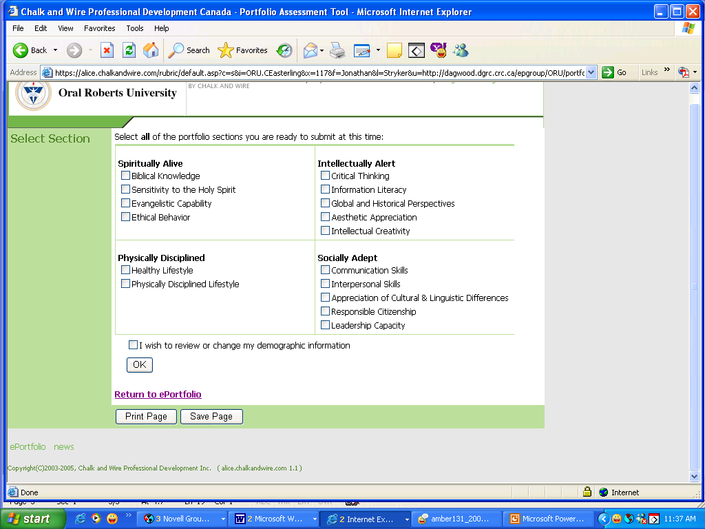

Second, you will need to select the rubric that goes with your artifact. Look at all the options carefully before selecting your rubric; if you choose the wrong rubric, your professor will not be able to assess your artifact. See below.

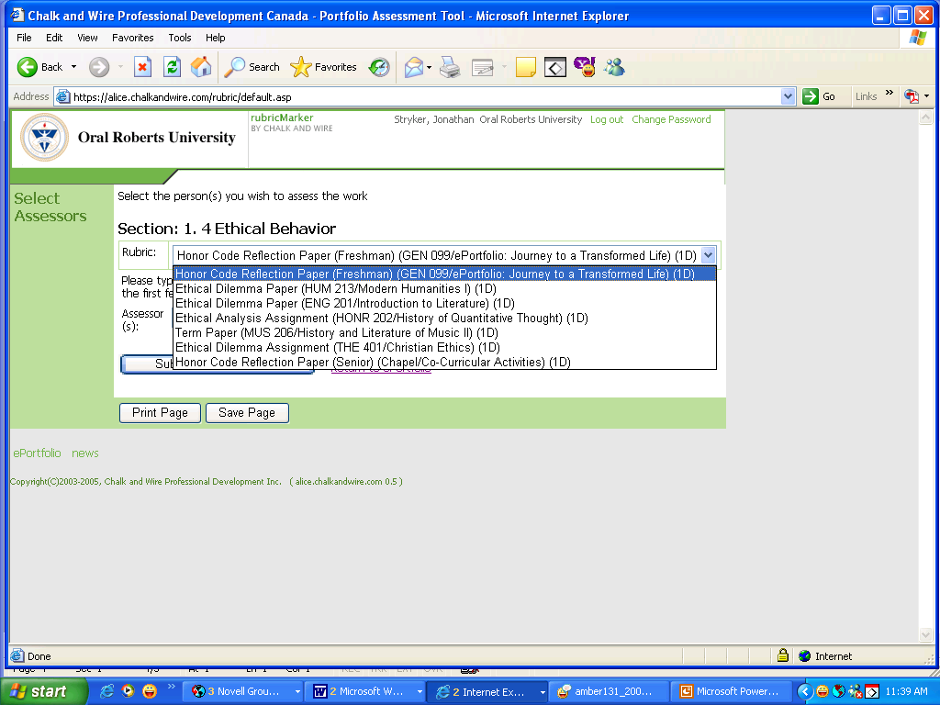
What should I do if I have several artifacts from different classes that need to occupy the same space in my ePortfolio (for instance, Evangelistic Capability)?
Keep all artifacts in your ePortfolio. Do not delete an artifact unless you are fixing a problem and resubmitting the artifact. You will ultimately end up with several artifacts in a given space. For instance, in the Evangelistic Capability sub-folder, you will end up with two Old Testament artifacts and a Charismatic Life artifact—and potentially Missions or Music Ministries artifacts as well. All appropriate artifacts must remain in the ePortfolio for the duration of your time at ORU.

I want to send my ePortfolio to my professor for assessment, but the “Assess” button is missing. What do I do?
Your ePortfolio is like any other website. You can work on it and change it all you like, but until you “publish” it, your changes will not be visible online. If the “Assess” button has disappeared, it means that you have made changes to your ePortfolio that have not been published. Once you publish your ePortfolio and return to where you started, the “Assess” button should reappear.

What if I don’t know my professor’s name?
Minimize the Internet window that has your ePortfolio open. Open a new Internet browser. Go to www.oru.edu, click on “Academics,” then click on “VISION: Enrollment and Registration System.” Log in to VISION, click “Student Services and Financial Aid,” click “Registration,” click “Student Detail Schedule,” and choose the correct term. You should then see your entire schedule including your professor’s name. When you have obtained the necessary information, log out of VISION, maximize the Internet browser with your ePortfolio, and continue the artifact submission process. [If you are submitting your artifact to a TA, you should follow the instructions given to you in your discussion group. Most TAs share generic Chalk & Wire accounts (for example, “1 CharismaticLife” or “2 BibLit”).]

How can I find out my professor’s assessment of my artifact?
Once you have submitted your artifact for assessment, you can click on the “Check Assessment” button on the main ePortfolio page (the page where you went to edit and submit your artifact). There you will see a listing of all artifacts that you have submitted for assessment. Once a professor completes the assessment, you will see a colorful bar graph delineating your score. In addition, you can view comments, if the professor has chosen to post comments.

Can I remove an artifact from my ePortfolio once I have successfully submitted it for assessment?
You should not remove an artifact from your ePortfolio unless (a) you are replacing it with a corrected version of the same document, (b) you have uploaded it in the wrong place and are correcting the error, or (c) you are deleting multiple versions of the same artifact. Your artifacts should remain in your ePortfolio for the duration of your time at ORU. If you remove them, then faculty will not be able to view them, and this may cause problems when your ePortfolio is audited at the end of a semester and prior to graduation.

How do I create my major ePortfolio?
You can create multiple portfolios within your Chalk & Wire account. One of these is your general education ePortfolio; another one will be your major ePortfolio. Follow the instructions for “Setting up Your ePortfolio” on p. 22 of this handbook. Please note that the following items will be modified when you set up your major ePortfolio:
- For #8, after choosing “Profile,” make sure the boxes next to both “General Education” and the name of your major have been clicked.
- For #12, use the name of your major in the title of this portfolio so you will be able to easily find it later. (For instance, if you are an English major, you might name this portfolio “English Major ePortfolio.”)
- For #16, choose the Table of Contents corresponding to your major.

Do I need to upload artifacts for electives or classes taken for my minor?
No. You are only required to submit artifacts for your general education classes and for the designated classes in your major.

Is there a way to know that my artifact has been placed successfully in my ePortfolio before I send it for assessment?
After you click on the “Assess” button but before you submit an artifact for assessment, you will see a split screen. The top screen is your actual, live, online ePortfolio—exactly what your professor will see. You can click on the folders and sub-folders to see where your artifact is and whether it will open in a readable format. Once you are sure that everything has been done correctly, follow the steps in the bottom half of the screen and submit your artifact.

What should I do when I think I uploaded my artifact correctly but I received communication from ORU that something with my ePortfolio was incomplete?
Follow the directions given in the letter/email/voice message that you received. If you are instructed to contact a specific individual, please do it as soon as you get the message. You are also welcome to contact the individuals monitoring the ePortfolio Help Line at 495-7356 (x7356 on campus) or ePortfolio@oru.edu and ask them to check your status in the Chalk & Wire system. Sometimes there is a problem with your actual ePortfolio account, and in these cases we need to fix it to avoid future problems. Other times, you may have inadvertently missed a step in the process. Often these things can be cleared up quickly and easily.

Where can I go to get ePortfolio help?
- ePortfolio Help Line at x7356 (918-495-7356) or ePortfolio@oru.edu
- 2nd Floor (GC) Academic Computing Lab, 8:00 a.m. to 10:30 p.m. most days
- ALSC office (3rd Floor, LRC, next to the Java Stop)—Ask for Dr. Gweth Holzmann or Jana Swartwood.
- ePortfolio Subadministrator in your major department
- Website: www.ePortfolio.oru.edu (many helpful resources)
- Your APA or ADD
- ePortfolio Help Nights (dates and times vary)

Whom should I contact if I have lost or forgotten my user name/password?
If you have lost or forgotten your user name or password, you can contact the ePortfolio Help Line (ePortfolio@oru.edu or 918-495-7356), visit Steve Duclos in the GC 2nd Floor Academic Computing Lab, or visit the School of LifeLong Education/Adult Learning Service Center on the 3rd floor of the LRC next to the Java Stop.

