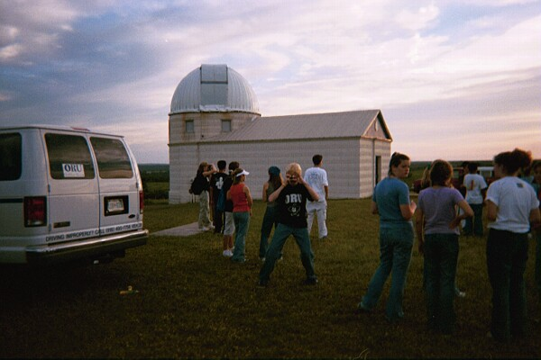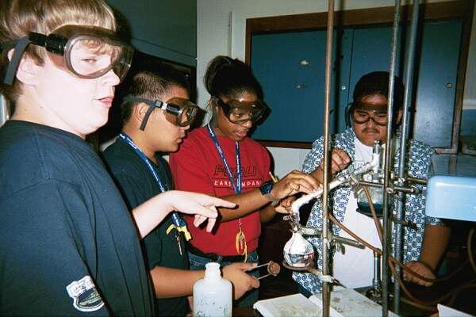**MCj03326800000[1]j0215086**

This residential summer academy will help students entering the 8th or 9th grade better understand the natural world and develop critical thinking skills through a series of integrated, project-based learning experiences. Field trips, laboratory experiences, and applied technologies will all be used to train students to explore, conjecture, and verify relationships in problem solving.

Campus facilities, such as basketball courts, swimming pool, and recreational fields, will be available to students during structured recreational time. Students will live on-campus in dorms supervised by Resident Advisors and security.

DISCLAIMER: Oral Roberts University, employees, coaches/instructors, trainers, volunteers, directors, members and representatives, are not responsible for any injury, loss or damage of any kind sustained by any person while participating in any and all summer camp sanctioned activities, events, outdoor sessions or lunch activities, including injury, loss or damage which might be caused by negligence.

**Math, Science, and Engineering Summer Academy**

*“A Hands-On Program in Mathematics and Science”*

Dr. John Matsson

School of Engineering

Oral Roberts University

7777 South Lewis Avenue

Tulsa, OK 74171

Phone: 918-495-6935

Fax: 918-495-7648

Email: jmatsson@oru.edu

Oklahoma State Regents for Higher Education

#### June 8-12, 2020

#### with a follow-up event on

#### August 22, 2020

For more information, or to return an application, contact:

Hosted by Oral Roberts University

##### **Highlights**

* Build and launch rockets
* Investigate a crime scene using DNA
* Take field trips to explore space and natural science
* Enjoy sports and fun activities

**ORAL ROBERTS UNIVERSITY**

**Math, Science, and Engineering Summer Academy Application**

## *“A Hands-On Program in Mathematics and Science”*

**June 8 - 12, 2020 and August 22, 2020**

***Application Procedure:***

1. Complete and submit this application.

1. Submit a completed Student Recommendation form from a Math or Science Teacher, Principal, or Counselor.
2. Submit a one-page essay indicating why you wish to participate in this program.
3. Commit to attend the fall follow-up activity on August 22, 2020.

***NOTES:***

1. Applicant must be entering the **eighth** or **ninth** grade in the Fall of 2020.
2. Social Security number *must* be recorded on application.
3. **Both forms** are to be completed & returned on/before deadline.
4. Accepted applicant must provide medical insurance information.
5. School transcripts and test scores are helpful but not required.
6. Selected participant should be on campus by 9:00am on Monday and picked up by 4:00pm on Friday.

***FOR THE STUDENT***

***Please print clearly. The Oklahoma Regents for Higher Education require the information below be completed.***

*LAST NAME FIRST NAME MIDDLE NAME □ Male □ Female*

*STREET ADDRESS APT.# SOCIAL SECURITY NUMBER GRADE LEVEL FOR FALL 2020*

*CITY*: *COUNTY*: *ZIP*: *BIRTHDATE: YYYY/MM/DD*

*NAME OF SCHOOL: LOCATION OF SCHOOL (County) LOCATION OF SCHOOL (City) STUDENT E-MAIL ADDRESS*

**For reporting purposes only:** *Please circle the word(s) that best describe(s) your ethnic background: American Indian/Alaska Native, Asian, Black/African American, Hispanic, Native Hawaiian/Other Pacific Islander, White, Two or More, Prefer not to respond or none of these apply.*

*Name of Parent/Guardian: ______________________________*

*Day Phone ( ) _________________ Evening Phone ( ) _______________*

*Cell Phone ( ) _______________ Alternate Cell Phone ( ) _______________ Parent/Guardian E-mail __________________________*

***Return application information to:***

### Dr. John Matsson

### School of Engineering ` Parent/Guardian Signature Date

*Oral Roberts University*

### 7777 South Lewis Avenue

*Tulsa, OK 74171*

*918-495-7648(fax); scanned application to jmatsson@oru.edu*

**APPLICATION DEADLINE:**  First Deadline: April 7, 2020; Second Deadline: April 27, 2020

Several hundred Oklahoma students are applying for State Regents Summer Academies. Students attending more than one State Regents Summer Academy may prevent many other students from having this opportunity. Although some Academies do not have waiting lists, others have very long waiting lists.

So that more students may attend a State Regents Summer Academy, I will notify Academy Directors if I am accepted for more than one 2020 Academy.

**Participant/Applicant signature_______________________________________________________________**

PERSONAL SKETCH

Please write a one-page personal sketch that explains:

* why you wish to participate in the program.
* your interest and achievements in math and science.
* your future job aspirations.

**This section weighs heavily in our selection process. Please type or write neatly. You may attach a separate typed page if you wish.**

______________________________ ________

Applicant Signature Date

**STUDENT RECOMMENDATION FORM**

**(This form to be completed by a** **Math or Science Teacher, Principal, or Counselor)**

**(Home school instructor is also acceptable)**

***Applicant:*** *Please complete the top section of this form. Give the form, along with a stamped envelope, to your Math or Science Teacher, Principal, or Counselor. Please print or type.*

*Applicant’s Name:______________________________________________________________________________*

Last First Middle

*Applicant’s Address:_____________________________________________________________________________*

Street Number City County Zip

*Applicant’s Telephone:* Daytime (____)__________________Evening (____)______________________

***(Optional)*** *I hereby waive my right of access to the material recorded below:*

*Signature of Parent/Guardian:___________________________________________Date____________*

*Signature of Applicant: ________________________________________________Date_____________*

**Evaluator: Please complete this form and mail, fax or email scanned form to Dr. John Matsson, School of Engineering, Oral Roberts University, 7777 S. Lewis Ave., Tulsa, OK 74171, (918) 495-7648 (fax), jmatsson@oru.edu. It is essential that your candid evaluation of this student be returned no later than *April 27, 2020*. Applicants CANNOT be considered without recommendations.**

Please circle the number that best represents your evaluation of this student, and write comments that may help us in our selection process.

# **Unsure Low 🡪 High PLEASE WRITE SPECIFIC COMMENTS ON EACH CATEGORY**

# Attention NA 1 2 3 4 5 __________________________________________________

# Attitude NA 1 2 3 4 5 __________________________________________________

Communication Skills NA 1 2 3 4 5 ____________________________________________________________

Cooperation NA 1 2 3 4 5 ____________________________________________________________

Diligence NA 1 2 3 4 5 ____________________________________________________________

Group Participation NA 1 2 3 4 5 ____________________________________________________________

Personal Maturity NA 1 2 3 4 5 ____________________________________________________________

Responsibility NA 1 2 3 4 5 ____________________________________________________________

**Acceptance into this program is competitive. On the back of this page, please tell us what makes this student stand out among his/her peers. Both positive and negative feedback is helpful.**

Overall, I (check one response) _____highly recommend, _____recommend, _____recommend with hesitation, or _____do not recommend this student for acceptance into this summer Academy.

*Evaluator: _______________________________Title:______________School Phone: _________________*

*School Address: ____________________________ City: _________________ State: _____ Zip: _________*