# **Operating Systems that Work with Respondus Lockdown**

* Chromebooks and Android devices, unfortunately, are not supported at this time.
* Apple iPads, on the other hand, are supported as long as they have iOS 11.0 or higher.
* It is recommend that all students reboot their device before taking the exam, including iPads, to avoid any testing issues.
* It is also necessary for the professor to [enable the iPad option](http://support.respondus.com/support/index.php?/default_import/Knowledgebase/Article/View/186/0/can-an-ipad-be-used-with-lockdown-browser) when setting up the quiz. The student instructions can be found [here](http://support.respondus.com/support/index.php?/Knowledgebase/Article/View/219/0/can-an-ipad-be-used-to-take-a-lockdown-browser-exam-instructions-for-students).

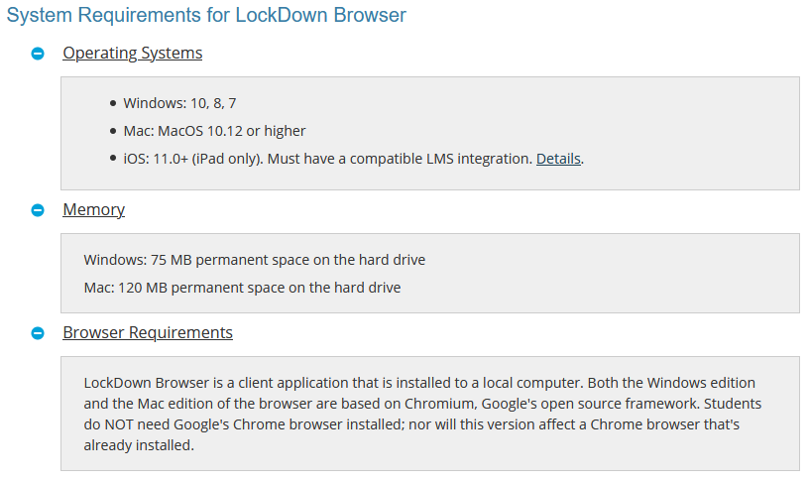

**Note:** The Respondus Lockdown Browser (the Chrome browser) and Respondus Monitor (the webcam portion) are two separate products that must be toggled by the professor.