School Choice Continues to Gain Ground


The word coming out of Washington, D.C. is that, concurrent with the commencement of the new administration, there has been a definite change in the disposition toward school choice from being very pro-private schools to anti-private schools at the K-12 level. While this noticeable shift in attitudes toward private schools and school choice exists at the federal level in the U.S., school choice and other pro-private school issues continue to make slow progress at the state level.
On May 28, 2009, Governor Brewer of Arizona signed a new $5 million corporate scholarship tax credit initiative designed to enhance educational opportunities for children with special needs and foster care students. According to John Schilling, the interim president of he Alliance for School Choice, “[the] passage of a new, and more robust school choice program in Arizona is a key victory for Arizona families, is smart public policy, and is a lifeline to the students whose educations were endangered. This decision is also a moral victory for families, who have fought hard to preserve educational opportunity for their children against an onslaught of litigation brought by special interest groups.”
In June, Indiana passed its first school choice initiative. Indiana lawmakers approved a $2.5 million scholarship tax credit program. As Robert Enlow, President and CEO of the Friedman Foundation said, “The state of Indiana … joined a growing number of states that are putting the educational needs of children before partisan politics by adopting school choice programs.” Indiana becomes the 11th state to offer private school choice programs.
More information on school choice, including a facts sheet appropriate for parents or other stakeholders visit the following website:
http://www.allianceforschoolchoice.org/PolicyMaker/#R

“Creating Sustainable Funding in Challenging Economic Times” Workshop Offered – FREE

ORUEF/ICAA has secured an agreement from Benevon, a company specializing in training nonprofit organizations to implement a mission-based system for raising sustainable funding, to provide their workshop, Creating Sustainable Funding in Challenging Times, as a free service to ORUEF/ICAA school representatives. The goal of the workshop is to help schools learn how to identify and cultivate donors who love the school’s mission – donors who will give for operations, capital, and endowment – even during challenging times – and who will become passionate and committed lifelong donors.

The workshop will be offered on Tuesday, June 29, 2010 immediately following the ICAA Delegate Assembly Meeting at ORUEF/ICAA in Tulsa. Since school administrators will already be present for the ICAA meetings and the ORUEF International Christian School Conference that begins the following morning, this is an excellent opportunity for ORUEF/ICAA school personnel to gain this valuable training. In addition, school administrators are encouraged to bring their development directors or other persons responsible for raising funds for their schools. A more complete description of the workshop is attached. You may view a 17-minute video presentation summarizing Benevon’s approach at:
http://www.benevon.com/online-video


Let’s Connect!

Are you a member of Facebook? If you are, then let’s connect. An ORUEF/ICAA group has been formed on Facebook. It’s a great way for ORUEF/ICAA administrators, faculties, and staffs to connect and network together to share ideas and information and discuss issues of mutual interest. Please click on the following link to join the ORUEF/ICAA Facebook group:
http://www.facebook.com/p.php?i=1352020627&k=Z5CT356SUVWBUCD1QB64USYVWQCJ.


H1N1 Swine Flu Virus Precautions

The federal government has released updated guidance and a new toolkit to help school officials prepare for, and respond to, the H1N1 flu in the 2009-10 school year. The guidance includes recommendations for school responses to flu outbreaks similar in severity to what took place this past spring as well as to potentially more severe outbreaks. The toolkit includes practical advice on how to contain the spread of flu, sample letters to parents, and posters related to flu prevention. Click on the links below to be taken to websites where you can receive your copies of the guidance and toolkit

Guidance: http://www.flu.gov/plan/school/schoolguidance.html
Toolkit: http://www.flu.gov/plan/school/schoolflutoolkit.pdf

Leadership Symposiums LOL

Planning is underway for the Old School to New School: Navigating the Changing Landscape of Education Leadership Symposiums scheduled this fall. These will explore the rapidly changing face of education precipitated by the phenomenon of Disruptive Innovation. The impact of Web 2.0, social networking, cloud computing and global collaboration on K-12 education will be examined and practical ways to incorporate these into classroom instruction will be presented. Attendance in the symposiums is by invitation only. Invitations will be mailed soon to prospective attendees.
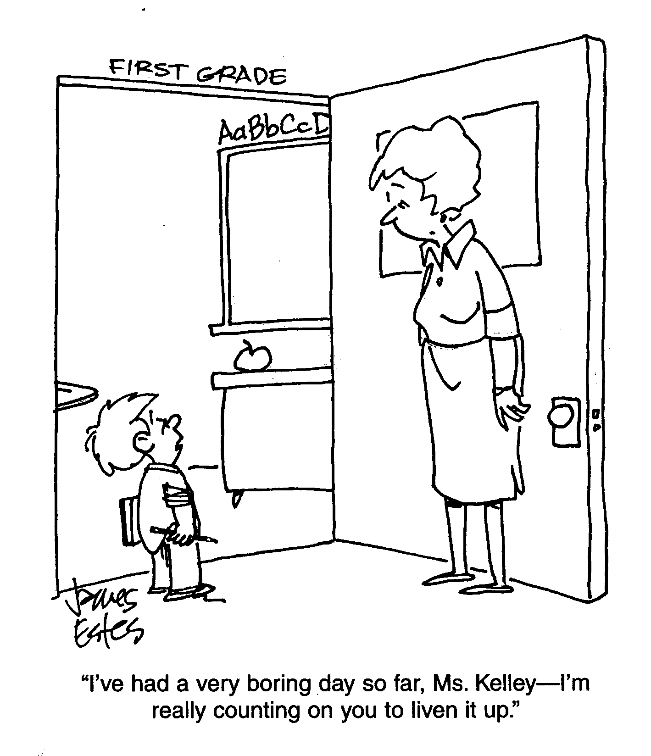

Upcoming Events – Mark Your Calendars!
Wednesday – Thursday, September 16-17, 2009 ICAA Annual PK-12 Accreditation Workshop
ICAA Training Center, Tulsa, OK
Friday, December 4, 2009 ORUEF Regional Christian School Conference
Albuquerque, New Mexico
Friday, January 15, 2010 ORUEF Regional Christian School Conference
Fort Worth, Texas
To subscribe/unsubscribe, or to give comments/suggestions regarding The Director’s Notebook,
please send an email to donpeal@oru.edu

