Curriculum Map: International Business

I = Introduced 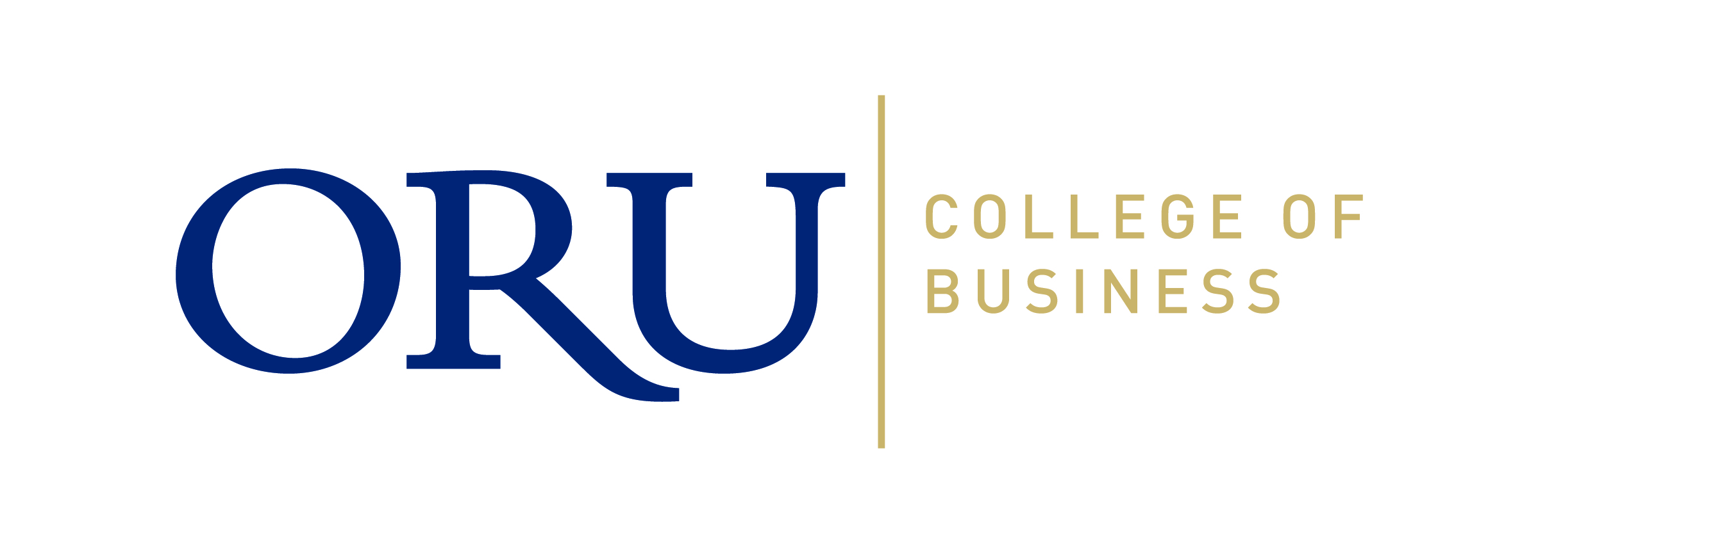
M = Mastered

 | Ethical Reasoning | Critical Thinking | Problem Solving | Information Literacy | Written Communication | Oral Communication | Global Perspectives | Teamwork | Professionalism | Christian Worldview
MGT 130 | I |  |  | I | I | I
MKT 130 | I |  |  | I | I | I
ACT 215 | I | I | I
ACT 216 | I | I | I
ACT 320 | I | I | M
BUS 325 | I | I
FIN 338 | I | I | M
MKT 361 | I |  | I | I | I | I
BUS 361 | I |  | I |  |  | I
BUS 499 | M | M |  | M | M | M
MGT 431 | M | M | M | M | M | M

