Management Major: Technical Knowledge
Direct, Summative Measure: Strategic Management Final Case
Rubric: Strategic Management Final Case Rubric
Criteria for Success: Mean of 3.0 or better
Student Learning Outcome: Mean of 3.75

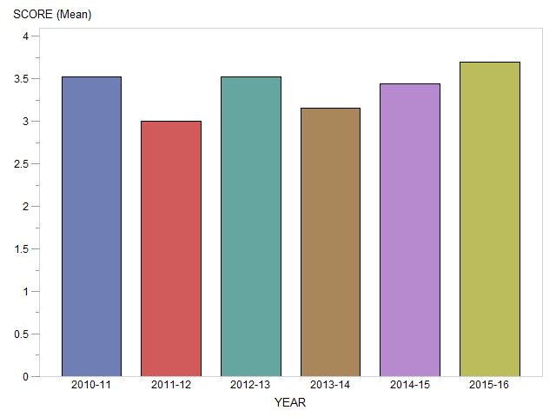

Generated on March 20, 2017

Management Major: Oral and Written Communication
Direct, Summative Measure: Strategic Management Final Case
Rubric: Strategic Management Final Case Rubric
Criteria for Success: Mean of 3.0 or better
Student Learning Outcome: Mean of 3.6

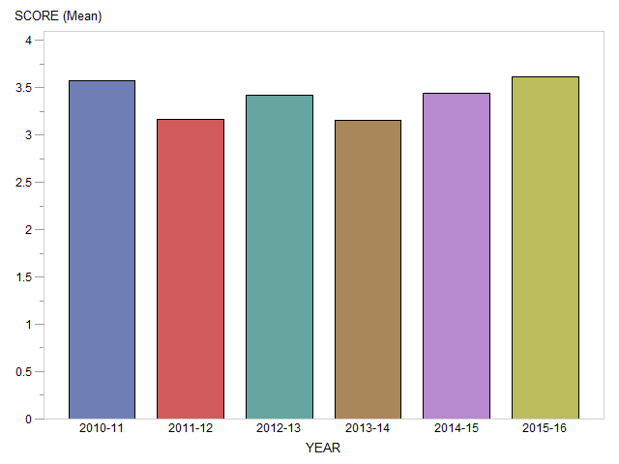

Generated on March 20, 2017

Management Major: Teamwork
Direct, Summative Measure: Strategic Management Final Case
Rubric: Senior Paper Team Skills Rubric
Criteria for Success: Mean of 3.0 or better
Student Learning Outcome: Mean of 3.7

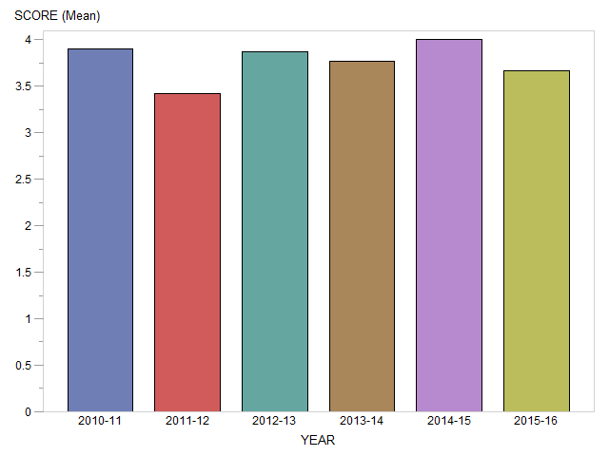

Generated on March 20, 2017

Management Major: Global Perspectives
Direct, Summative Measure: Strategic Management Final Case
Rubric: Strategic Management Final Case Rubric
Criteria for Success: Mean of 3.0 or better
Student Learning Outcome: Mean of 3.76

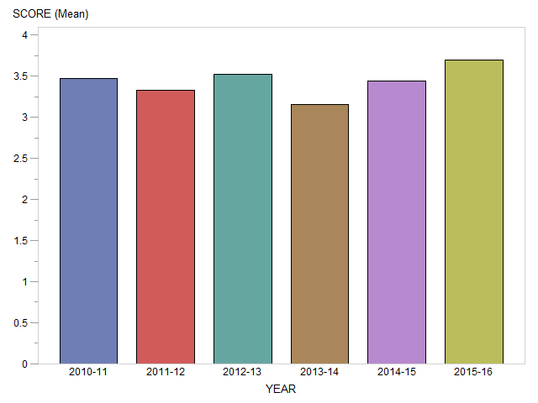

Generated on March 20, 2017

Management Major: Professionalism
Direct, Summative Measure: Strategic Management Final Case
Rubric: Strategic Management Final Case Rubric
Criteria for Success: Mean of 3.0 or better
Student Learning Outcome: Mean of 3.74

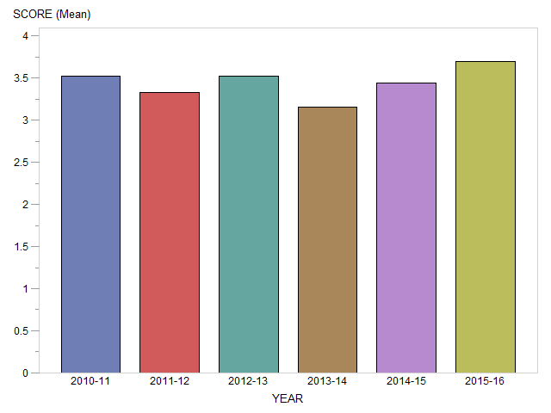

Generated on March 20, 2017

Management Major: Critical Thinking
Direct, Summative Measure: Strategic Management Final Case
Rubric: Strategic Management Final Case Rubric
Criteria for Success: Mean of 3.0 or better
Student Learning Outcome: Mean of 3.75

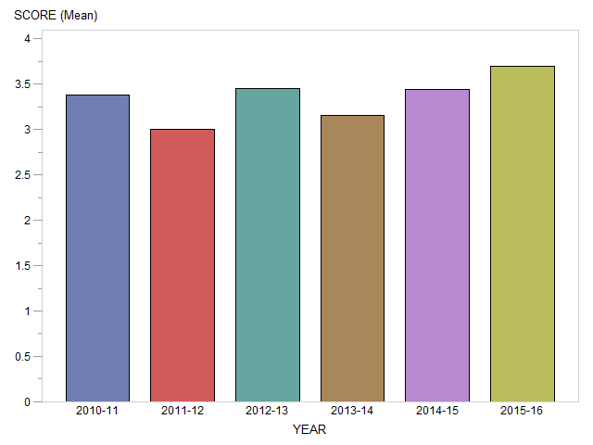

Generated on March 20, 2017

Management Major: Problem Solving
Direct, Summative Measure: Strategic Management Final Case
Rubric: Strategic Management Final Case Rubric
Criteria for Success: Mean of 3.0 or better
Student Learning Outcome: Mean of 3.75

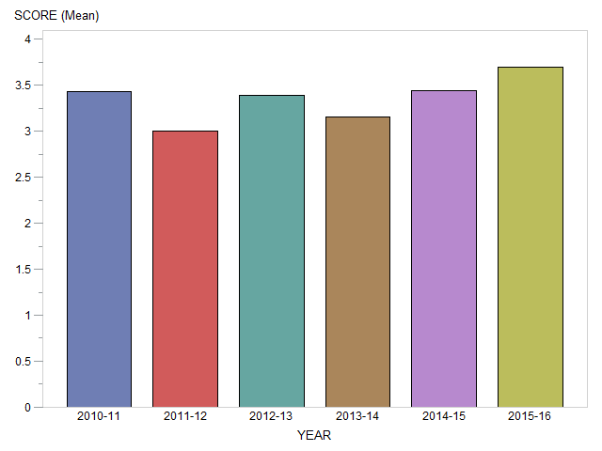

Generated on March 20, 2017

Management Major: Information Literacy
Direct, Summative Measure: Strategic Management Final Case
Rubric: Strategic Management Final Case Rubric
Criteria for Success: Mean of 3.0 or better
Student Learning Outcome: Mean of 3.75

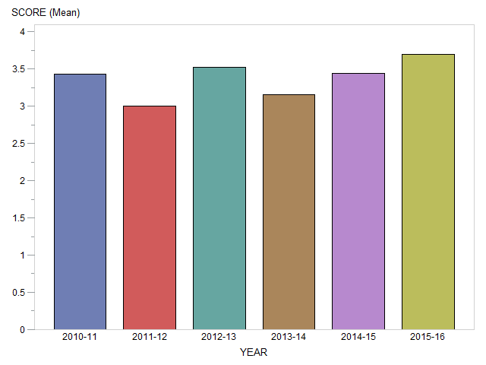

Generated on March 20, 2017

